Group: Willow/Rowan/Kingfisher/Greenfinch |  | Subject: Drama | Term: 2
Teacher: Steph Kirton/Charlotte Cox/Kay Sherburn
Curriculum: Drama intro for all

Term focus:

Drama fundamentals: Character and script – Grimsby Gore Mansion

Drama fundamentals: Slapstick and Farce

 | To create character and story in response to a teacher in role
 | To devise a story and tell it in character
 | To respond and react in character
 | To recognise the basic formatting of play scripts; including the use of stage directions and punctuation to make decisions about performance
 | To apply rehearsal techniques to develop and refine performance
 | To perform for a small audience and reflect on WWW and EBI
 | To recognise the fundamentals of slapstick performance and how it generates comedy
 | To recognise the fundamentals of farce and how it generates comedy
 | To make connections between slapstick comedy and Commedia Del Arte
 | To create a physical scene that mimics the style of Charlie Chaplin (slapstick)
 | To create a scene based on mistaken identity and show a build in chaos (farce)
 | To create a scene using a stimulus
 | To perform a devised scene to a small audience
 | To give feedback on other performances
Resources:
Drama games, ideas and fun videos to watch - https://dramaresource.com/videos/
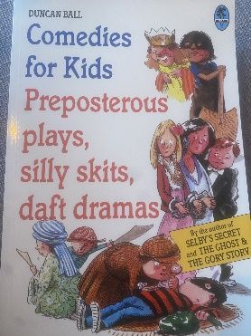
The difference between slapstick and Farce https://www.youtube.com/watch?v=gUnvYRknycI&t=142s
Chaplin examples - https://www.charliechaplin.com/en/videos
Commedia Del Arte - extension learning - https://www.nationaltheatre.org.uk/learn-explore/schools/teacher-resources/commedia-dellarte-education-resource/
Keywords:
Exaggeration | Physical comedy | Comic Timing | Pace | Repetition
Overacting | Misdirection | Status | Characterisation | Motivation
Backstory | Subtext | Objective

