Group: Aspen |  | Subject: Writing for Pleasure  (Fairy tales) | Term: 2
Teacher: | Emily Watson
Curriculum: Worsborough Connect

Term 2 focus:
write sentences by:
- saying out loud what they are going to write about
- composing a sentence orally before writing it
- sequencing sentences to form short narratives
- re-reading what they have written to check that it makes sense
- leaving spaces between words
- joining words and joining clauses using and
- beginning to punctuate sentences using a capital letter and a full stop, question mark or exclamation mark
- Expanded noun phrases for description and specification
1. | To understand the purpose of the new writing project and the intended publishing outcome.
2. | To understand what a finished text should look like and who it is written for.
3. | read like writers, identifying techniques used by authors.
4. | identify features of mentor texts to use in their own writing.
5. | establish product goals based on high-quality texts.
6. | study a chosen author and apply elements of their style to their own writing.
7. | generate and share ideas for their own writing.
8. | select and develop an idea into a full piece of writing.
9. | use expanded noun phrases to add detail and description.
10. | use prepositional phrases to add information about time, place, or direction.
11. | use coordinating conjunctions to join clauses and ideas.
12. | proof-read their writing to ensure correct use of capital letters.
13. | proof-read their writing to ensure correct use of full stops.
14. | spell common words accurately.
15. | use temporary spellings to support independent writing.
16. | publish their writing in a finished form suitable for an audience.
Recommended reads:
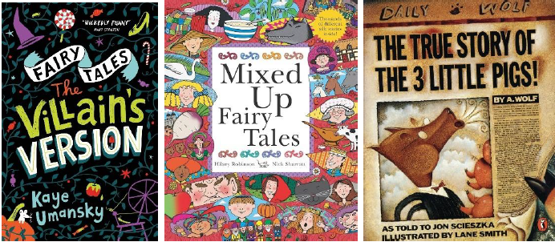
Tier Three Keywords


