Group: Aspen and Cedar |  | Subject: Arts and Tech (Food) | Term: 2
Teacher: | Emily Watson and Aga Kozwolska
Curriculum: Worsborough Connect

Term 2 focus:
- understand and apply the principles of a healthy and varied diet
- prepare and cook a variety of predominantly savoury dishes using a range of cooking techniques
 | Objective | Attendance | How I felt about it  
 |  | (Date unit finished) | Student assessment | Teacher
1. | design a simple food product by selecting ingredients, considering taste, texture, and presentation
2. | prepare and assemble a healthy sandwich, following safe food handling and hygiene practices.
3. | prepare and cook a pizza, selecting toppings and using safe cooking techniques.
4. | prepare and combine ingredients to make a pasta dish, demonstrating basic cooking skills and hygiene awareness.
Recommended reads:
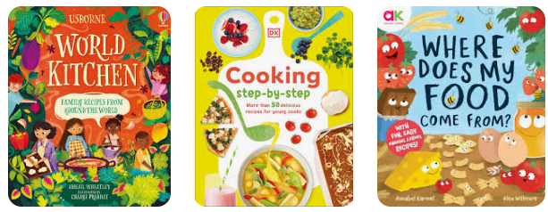
Tier Three Keywords


