Group: Aspen and Cedar |  | Subject: Arts and Tech (Textiles) | Term: 2
Teacher: | Emily Watson and Aga Kozwolska
Curriculum: Worsborough Connect

Term 2 focus:
- design purposeful, functional, appealing products for themselves and other users based on design criteria
- select from and use a wide range of materials and components, including construction materials, textiles and ingredients, according to their characteristics
- explore and evaluate a range of existing products
- evaluate their ideas and products against design criteria
 | Objective | Attendance | How I felt about it  
 |  | (Date unit finished) | Student assessment | Teacher
1. | To investigate a range of puppets and their features.
2. | To be able to work with fabric to create a finger puppet.
3. | To develop and practise sewing skills.
4. | To be able to design a glove puppet.
5. | To be able to follow a design to make a puppet.
6. | To be able to evaluate a finished product.
Recommended reads:
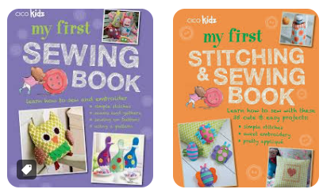
Tier Three Keywords


