Group:  Greenfinch |  |  | Subject:  English | Term:2  Spring 2026
Teacher: |  | Charlotte Cox
Autumn 2 – West Riding Classes

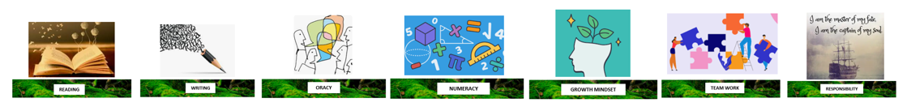
1 | To identify some relevant points in a text using evidence from the text.
2 | To make inferences based on evidence from a variety of short stories across different points of the text.
3 | Identify structural choices with a simple comment on the effect, identifying basic organisational features.
4. | Identify the writer’s use of language in a short story and begin to discuss the effect.
5. | Identify common features and effect that the writer’s context has on the meaning.
6. | Organise writing effectively by clustering related points or by time sequence in a logical way.
7. | Use paragraphs to organise content, with some links between sections.
8. | Use a variety of sentence structures and lengths.
9. | Identify deliberate vocabulary choices and begin to discuss their effect. Some expansion of general vocabulary to match the topic.

Tier Three Keywords:
TBC
Recommended Reading:
TBC

