Group:  Rowan |  |  | Subject:  English | Term:2  Spring 2026
Teacher: |  | Ozlem Demirezer
Autumn 2 – West Riding Classes

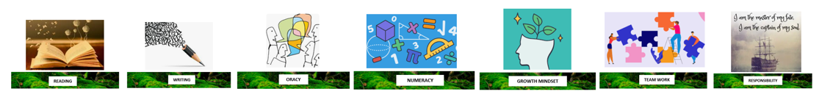
1 | To identify some relevant points in a text.
2 | To make inferences based on evidence from a variety of short stories.
3 | Identify structural choices with a simple comment on the effect.
4. | Identify the writer’s use of language in a short story and begin to discuss the effect.
5. | Identify the main purpose of the text.
6. | Organise writing effectively by clustering related points or by time sequence.
7. | Use paragraphs to organise content.
8. | Use a variety of sentence structures and lengths.
9. | Identify deliberate vocabulary choices and begin to discuss their effect.

Tier Three Keywords:
TBC
Recommended Reading:
TBC

