Group:  Willow |  |  | Subject:  English | Term:2  Spring 2026
Teacher: |  | Jodie Burgin
Autumn 2 – West Riding Classes

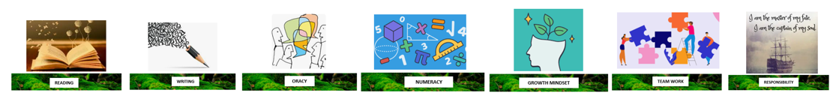
1 | To identify simple points in a text.
2 | To make straightforward inferences based on a single point of reference in a text.
3 | Identify some structural choices with a some comment on the effect.
4. | Identify the writer’s use of language in a short story.
5. | Comment on the main purpose of a text.
6. | Some attempt to sequence ideas.
7. | Within paragraphs, some links between sentences. E.g. use of pronouns or adverbials.
8. | Use of ‘and’ and ‘but’ to extend sentences, subordination used occasionally.
9. | Some words chosen for effect or occasion.

Tier Three Keywords:
TBC
Recommended Reading:
TBC

