Group: Aspen and Cedar |  | Subject: Geography | Term: 2
Teacher: | Emily Watson and Aga Kozwolska
Curriculum: Worsborough Connect

Term 2 focus:
- identify seasonal and daily weather patterns in the United Kingdom and the location of hot and cold areas of the world in relation to the Equator and the North and South Poles.

- use world maps, atlases and globes to identify the United Kingdom and its countries, as well as the countries, continents and oceans studied at this key stage.

- use simple compass directions (North, South, East and West) and locational and directional language [for example, near and far; left and right], to describe the location of features and routes on a map.
 | Objective | Attendance | How I felt about it  
 |  | (Date unit finished) | Student assessment | Teacher
1 | Use maps, atlases and globes to identify the UK and other countries, continents and oceans Identify the UK on a map
2 | Locate the seven continents on a map
3 | Locate the five oceans on a map
4 | Locate the Equator, North and South Pole on a map
5 | Know and explain features of weather in each season in the UK
Recommended reads:
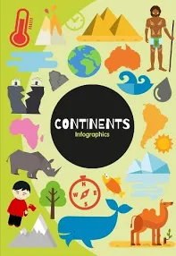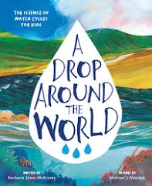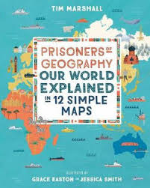
Tier Three Keywords


