Group: Aspen and Cedar |  | Subject: PEA | Term: 2
Teacher: | Emily Watson and Aga Kozwolska
Curriculum: Worsborough Connect

Term 2 focus:
- By the end of this outcome, the pupil will demonstrate increasing independence in accessing the local community. They will travel safely on familiar routes, including walking alongside roads and crossing safely, navigate the local area of Worsborough with growing confidence, and use local resources. The pupil will take part in planning journeys, respond appropriately to problems encountered while travelling, and independently manage their personal safety when engaging in everyday community activities.
 | Objective | Attendance | How I felt about it  
 |  | (Date unit finished) | Student assessment | Teacher
1. | Consistently walks safely by the side of road locally
2. | Consistently crosses road safely
3. | Finds own way around local area (Worsborough) learning about local resources
4. | Helps to plan a journey or trip out to learn about different people and local events
5. | Solves problems that may occur while travelling
6. | Begins to independently manages safety needs while interacting with the local area
Recommended reads:
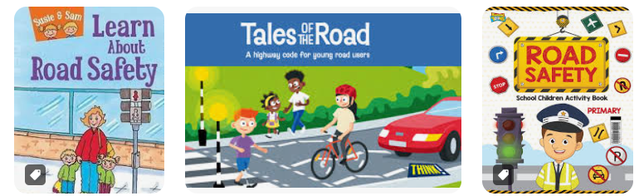
Tier Three Keywords


