Group:  Kingfisher |  |  | Subject:  PSHE | Term:2  Spring 2026
Teacher: |  | Kay Sherburn
Spring two – West Riding Classes – Drugs, Alcohol and Tobacco; First Aid; Social Influences.
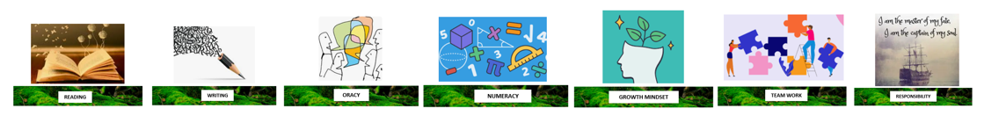
1 | The consequences of substance use and misuse for the mental and physical health and wellbeing of individuals and their families, and the wider consequences to communities
2 | Wider risks of illegal substance use for individuals, including for personal safety, career, relationships and future lifestyle.
3 | to identify, manage and seek help for unhealthy behaviours, habits and addictions including smoking cessation
4. | strategies for identifying risky and emergency situations, including online; ways to manage these and get appropriate help, including where there may be legal consequences (eg drugs and alcohol, violent crime and gangs)
5. | to increase confidence in performing emergency first aid and life saving skills, including CPR and the use of defibrillators
6. | to evaluate ways in which their behaviours may influence their peers, positively and negatively, including online, and in situations involving weapons or gangs
7. | skills to support younger peers when in positions of influence
8. | to recognise situations where they are being adversely influenced, or are at risk, due to being part of a particular group or gang; strategies to access appropriate help
9. | factors which contribute to young people becoming involved in serious organised crime including cybercrime
10. | The consequences of substance use and misuse for the mental and physical health and wellbeing of individuals and their families, and the wider consequences to communities

Tier Three Keywords:
TBC
Recommended Reading:
TBC

