Group:  Greenfinch |  |  | Subject:  PSHE | Term:2  Spring 2026
Teacher: |  | Charlotte Cox
Spring two – West Riding Classes – Managing risks around drugs, alcohol and tobacco; First Aid; Digital literacy

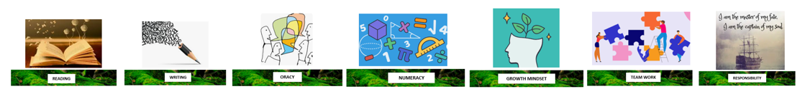
1 | the purpose of blood organ and stem cell donation for individuals and society
2 | how to take increased personal responsibility for maintaining and monitoring health, including cancer prevention, screening and self- examination
3 | to assess and manage risks associated with cosmetic and aesthetic procedures including tattooing, piercings and the use of sunbeds
4. | the ways in which industries and advertising can influence health and harmful behaviours
5. | to increase confidence in performing emergency first aid and life- saving skills including CPR and the use of defibrillators
6. | to understand the potential impact of the portrayal of sex in pornography and other media, including on sexual attitudes, expectations and behaviours
7. | the impact of sharing sexual images of others without consent
8. | how to manage any requests or pressure to share any images of themselves or others and how to get help
9. | to evaluate different motivations and contexts in which sexual images are shared, and the possible legal, emotional and social consequences
10. | to understand how the way people present themselves online can have positive and negative impacts on them

Tier Three Keywords:
TBC
Recommended Reading:
TBC

