Group:  Rowan |  |  | Subject:  PSHE | Term:2  Spring 2026
Teacher: |  | Ozlem Demirezer
Spring two – West Riding Classes – Managing risks around drugs, alcohol and tobacco; First Aid; Digital literacy

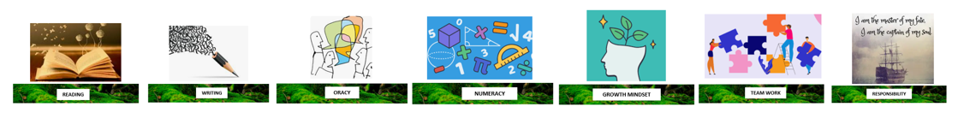
1 | The positive and negative uses of drugs in society, including the safe use of prescribed and over the counter medicine; responsible use of antibiotics
2 | to evaluate misconceptions, social norms and cultural values relating to drug alcohol and tobacco use
3 | Strategies to manage a range of influences on drug, alcohol and tobacco use, including peers
4. | information about alcohol, nicotine and other legal and illegal substances, including the short term and long term health risks associated with their use
5. | the personal and social risks and consequences of substance use and misuse including occasional use
6. | the law relating to the supply, use and misuse of legal and illegal substances
7. | about the concepts of dependence and addiction including awareness of help to overcome addictions
8. | How to get help in an emergency and perform basic first aid, including cardio pulmonary resuscitation and the use of defibrillators
9. | the benefits and positive use of social media, including how it can offer opportunities to engage with a wide variety of views on different issues
10. | that features of the internet can amplify risks and opportunities, eg speed and scale of information sharing, blurred public and private boundaries, and a perception of anonymity

Tier Three Keywords:
TBC
Recommended Reading:
TBC

