Group: Aspen and Cedar |  | Subject: PSHE (Communities) | Term: 2
Teacher: | Emily Watson and Aga Kozwolska
Curriculum: Worsborough Connect

Term 2 focus:
- about what rules are, why they are needed, and why different rules are needed for different situations
- how people and other living things have different needs; about the responsibilities of caring for them
- different roles and responsibilities people have in their community
- that jobs help people to earn money to pay for things
- to recognise the ways in which they are the same and different to others

 | Objective | Attendance | How I felt about it  
 |  | (Date unit finished) | Student assessment | Teacher
1. | Understand why we have rules and how they help us to be happy
2. | Understand how to behave appropriately and contribute to school life
3. | Appreciate how important school is to them
4. | Identify special people in school
5. | Know what range of communities live near school
6. | Appreciate that people should be treated with kindness regardless of difference
7. | Understand what to do if they feel uncomfortable with strangers or people they know
8. | Understand that money comes from doing jobs
9. | Appreciate that different jobs are suited to different people
10. | Understand basic decisions about money such as saving and spending
Recommended reads:
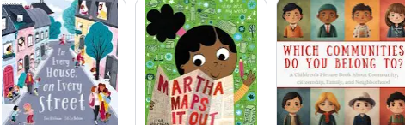
Tier Three Keywords


