Group: WR05 |  | Subject: Science | Term: 2
Teacher: | Charlotte Cox
Curriculum: Secondary One Exploring
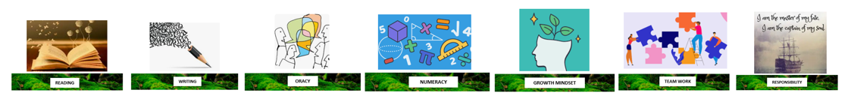
 |  | Objective | Attendance | How I felt about it  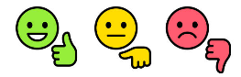
 | 1 | Describe parts of the digestive system and how food is digested | (Date when taught) | End of  lesson | 4 weeks later | End of year
 | 2 | Describe the processes of mechanical and chemical digestion that break down food to release nutrients
 | 3 | Carry out tests for nutrients and some of the substances they are broken down into
 | 4 | Describe the important roles of bacteria in the human digestive system
 | 5 | Describe how the digestive system and circulatory system work together to absorb nutrients
 | 6 | State the primary colours of light, how they mix to produce other colours and how the eye detects them
 | 7 | Describe what white light is
 | 8 | Explain the colour of an object in white light and coloured light
 | 9 | Explain how light passes through a pinhole to produce an image in a pinhole camera
 | 10 | Describe the properties of reflections in a plane mirror and draw diagrams to show how reflections form
 |  | I can explain how light from an object can be focused by a converging lens to form an image
Tier Three Keywords:
Recommended Reading:

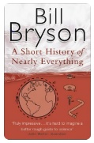Bill Bryson

A short history of nearly everything.

A stunning book, that highlights the history of science through the ages. Arguably one of the best books I have ever read (at least 5 times).

