Science Term 2 Objectives - Rowan Class
Sec One Exploring // Oak Academy Year 6 curriculum

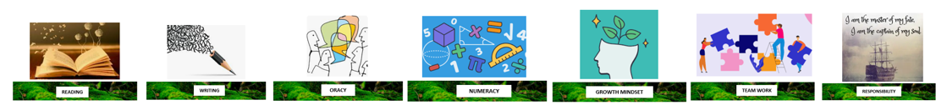
Biology- The human circulatory system
- I can describe what the human heart is and what it does.
- I can describe what blood is and what it does.
- I can describe what blood vessels are and what they do.
- I can describe how water and nutrients from food travel through the body.
- I can draft information about the circulatory system in humans and plan how to present it to others.
- I can use a plan to present information about the circulatory system in humans to other people.
- I can consider arguments for and against the use of animal’s heart to repair or replace human heart.
Physics -Light and how it travels
- I can explain that light travels in straight lines.
- I can describe the difference between light source and light reflectors.
- I can explain that we see things when light travels into the eye.
- I can explain that we see things when light is reflected from an object into the eye.
- I can explain how mirrors are reflective materials that are used to change the direction in which light travels.
- I can plan an investigation to see how changing the angle of a mirror affects the angle of reflected light.
- I can use the idea of light travelling in straight lines to explain shadow shape.
- I can investigate the number of shadows that can be cast by an object.

Biology
Keeping health
Why we group and classify living things
Evolution and inheritance
Chemistry- there isn’t any
Physics
Changing circuits

