Term 2 Science Objectives January to Easter
Willow (Sec Ready // Oak Academy Year 5 Curriculum)
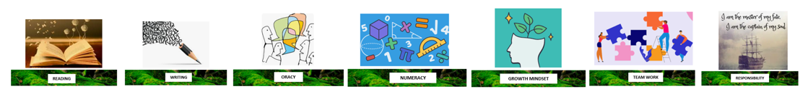
Biology:
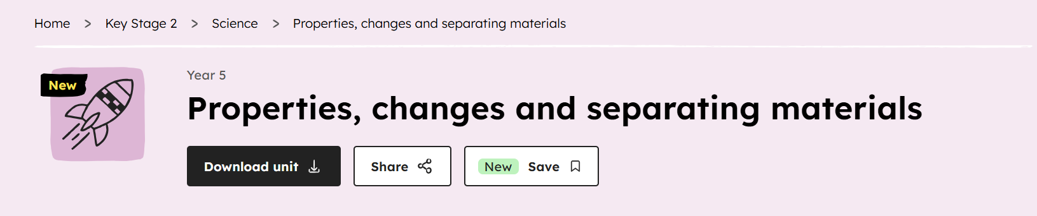
- I can compare and group together materials based on their simple properties: rigidity, transparency, electric conductivity and magnetism.
- I can use test results to explain some uses of everyday materials.
- I can plan and carry out a comparative test and explain which cup is most suitable for keeping warm water warm.
- I can identify and name thermal insulators in everyday life.
- I can compare materials based on whether they are soluble or not.
- I can describe how to separate an insoluble solid from a liquid
- I know that changes of state are reversible changes.
- I can demonstrate how mixing and dissolving are reversible changes
- I can describe burning and rusting as irreversible changes, where a new material is formed.

Chemistry:
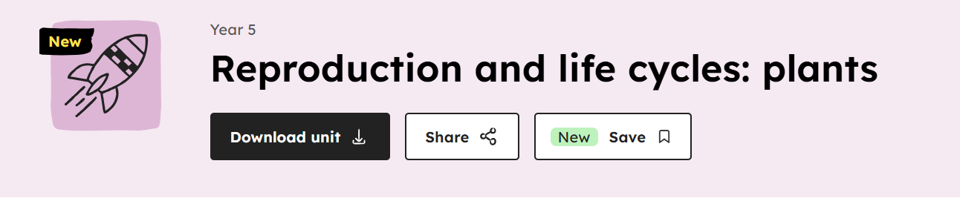
- I can explain how plants can reproduce asexually.
- I can explain how to reproduce new plants from cuttings.
- I can describe the life process of sexual reproduction in flowering plants.
- I can research and present the life cycles of different plants.
- I can describe the process of plant reproduction from cuttings, based on my own observations.

