Group: Aspen and Cedar |  | Subject: Science | Term: 2
Teacher: | Emily Watson and Aga Kozwolska
Curriculum: Worsborough Connect

Term 2 focus:
- identify, name, draw and label the basic parts of the human body and say which part of the body is associated with each sense.
- find out about and describe the basic needs of animals, including humans, for survival (water, food and air)
- describe the importance for humans of exercise, eating the right amounts of different types of food, and hygiene
 | Objective | Attendance | How I felt about it  
 |  | (Date unit finished) | Student assessment | Teacher
1. | Identify, name, draw and label (basic parts of the human body and say which part of the body is associated with each sense)
2. | Explain the basic needs of humans for survival animals include water, food and air (oxygen)
3. | Explain how humans can stay healthy
4. | Know that a variety of foods help humans maintain a healthy diet
Recommended reads:
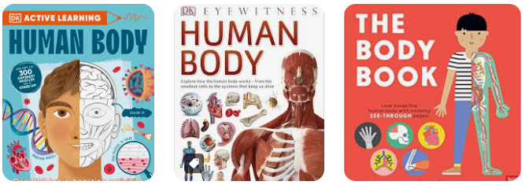
Tier Three Keywords

