Group: EW07 |  |  | Subject: English | Term: 2 | Step: 5
Teacher: |  | Alex Bird
Curriculum: Higher Education Ready 3
Term 2 focus:
HT3 - Short Stories and Creative Writing
HT4 - 20th Century Play

Our third half term focuses on both reading and writing skills, and as a class we will be reading various short stories and extracts centring on the dystopian genre. We will connect to the teaching of HT1 as we will analyse writers’ purpose and structural choices. Throughout the half term, we will evaluate the writers’ use of language techniques and begin to implement them in our own pieces of writing. Students will then demonstrate capability in writing their own stories, using elements which they have gained from the studied texts. Students will show clear understanding through discussions and written responses and will be provided with several opportunities to showcase different sequences and structure types.

The focus for the second half term is looking at the 20th century play An Inspector Calls. As a class, we will develop understandings of dramatic conventions as we analyse characters, settings and plot. Across the course of the half-term, students will have lots of opportunities for performance and discussion.

Reading:
HT1: Structure.
HT2: Discussion of ideas, themes and contemporary issues arising from the text.

KO4 | I am aware that writers craft their writing by making structural choices. I identify and explain organisational features.
KO5 | explain and comment on writers’ use of language, including grammatical and literary features at word and sentence level
KO6 | I can identify and comment on writers’ perspectives and viewpoints, and the overall effect of the text on the reader
Writing:
HT1: Creative
HT2: Writing to support talk

KO2 | My purpose is clear and features of the form are adapted to the purpose. My appropriate style maintains the reader’s interest.
KO3 | I structure clearly w paragraphs. I develop material. I signal direction by links between paragraphs
KO4 | I use paragraphs etc to structure writing & achieve purpose. Links between paragraphs more developed

Tier Three Keywords:
infer | identify | audience | theme | survival
evaluate | purpose | present | setting | Analyse
context | character | malevolent | hierarchy | voice

Recommended Reading:

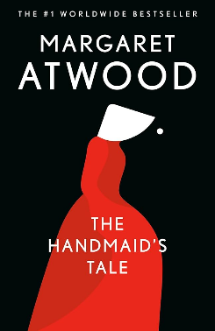

The Handmaid’s Tale by Margaret Atwood

The Handmaid's Tale is an instant classic and eerily prescient cultural phenomenon, from the patron saint of feminist dystopian fiction The Handmaid’s Tale is a novel of such power that the reader will be unable to forget its images and its forecast.

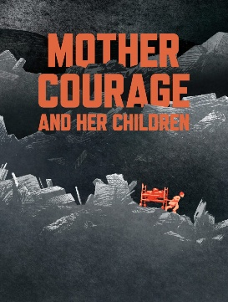

Mother Courage and Her Children by Bertolt Brecht
Mother Courage and Her Children is Bertolt Brecht's epic anti-war play following Anna Fierling, "Mother Courage," a canteen woman who profits from the Thirty Years' War by selling supplies to armies, but tragically loses each of her children to the conflict she exploits, powerfully showing how no one escapes war's devastating cost, even those who try to profit from it.

