Group:  P16 EW |  |  | Subject:  Horticulture | Term: 2  Jan 2026
Teacher: |  | Becky Wilcox
Curriculum: Land-based studies Level 1
Term 2 focus: to review with the learner the fundamental skills to prepare soil for sowing and planting.
1 | Prepare evidence for Personal Progression Plan
2 | Review long-term and short-term goals and write up progression plan. Review skills needed for the plan. Research and share ideas for the Allotment.
3 | Review Health and Safety, use of tools and correct clothing/protection.
4 | To be able to select and use correct tools for the construction of a raised bed and associated planting
5 | To be able to use equipment for preparing soil
6 | To be able to test the soil
7 | To be able to clear a site of unwanted debris for the erection of the raised bed.
8 | To be able to load, transport and spread bulky organic matter
9 | To demonstrate forking and raking
10 | To demonstrate soil consolidation, levelling and tilth production for (a) seeding, broadcast or in drills & (b) planting.
11 | To carry out any necessary preparation of the planting medium according to instructions.
Tier Three Keywords:
feature | collaborate | organise | monitor | nutrition | wellbeing
species | soil | routine
Recommended Reading:
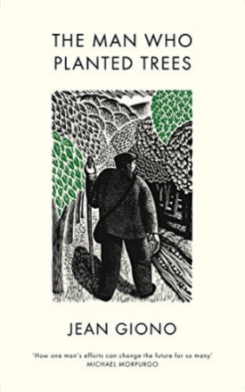
Assessment
Record and annotate steps to prepare soil and propagate seeds.

