Group: B11/ 6th Form English BR |  |  | Subject: English | Term: 3
Teacher: |  | Molly Vellacott
Curriculum: Sixth Form Deepening (Step 5)
Term 3 focus:
HT5 – Speaking and Listening and Classic Play

In this half term we will have the opportunity to foreground speaking, listening and communication skills and plan and record an individual presentation on a chosen topic which will be suitable for both GCSE and Functional Skills Level 1 or 2. There will also be an opportunity to participate in the recorded class discussion necessary for the Functional Skills qualification. All students will be able to practise and deepen their communicative skills using the objectives they have become familiar with already.

We will use the themes of The Crucible by Arthur Miller as the basis for discussion. We will use the film of the play as well as performing extracts.

HT6 – Poetry
We will use poetry as a way to explore our use of language for enjoyment and self-expression, studying a range of poetry by writers in various genres and traditions, learning about different poetic methods and forms whilst experimenting with using their techniques to create our own poetry, ultimately creating a small anthology of our poems.

Reading:
HT1: Understanding the text and using evidence
HT2: Self-expression and enjoying the text

KO1 | I can identify relevant points from varied places. I support comments, ideas with relevant references
KO3 | I am aware that writers craft their writing by making structural choices. I identify and explain organisational features.
KO4 | I am aware that writers craft their writing by making structural choices. I identify and explain organisational features.
KO5 | I can identify language features which the writer has chosen to use and develop some explanation of them.
KO6 | I can clearly identify the author’s main purpose and perspectives and have a general overview of the text. I am aware of and can generally explain effect on reader.
KO7 | I can identify similarities, differences between texts with some explanation. Also how contexts contribute to meaning.
Writing:
HT1: Effective organisation of ideas and evidence
HT2: Writing poetry

KO1 | I include some imaginative ideas and shape material appropriately. Viewpoint is clear, generally consistent.
KO3 | I control & sequence writing taking account of reactions. Range of features clearly signal direction.
KO4 | I use paragraphs etc to structure writing & achieve purpose. Links between paragraphs more developed
KO5 | I vary sentences for clarity, emphasis. Connectives relate ideas. Can structure for detail, nuance
KO6 | I use full range of punctuation accurately. Syntax, punctuation within sentences generally accurate
KO7 | I use a fairly wide vocabulary, often appropriately and choose words for effect.

Tier Three Keywords:
Paralinguistic features | allegory | stanza | line break
Turn-taking | adversary | metaphor | speaker
Register | Stage direction | Semantic field | anthology
dialogue | scapegoat | symbol | meter

Recommended Reading:

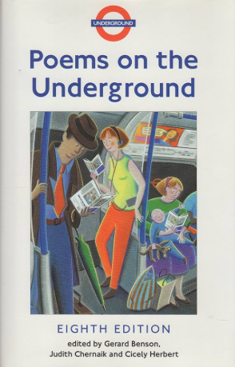
Poems on the Underground
This collection of shortish poems which have all appeared on the London Underground provides an accessible snapshot of some of the kinds of things poets publish and want you to read. One of the joys of poems is that you can read a lot of them, helping you to gain a sense of what kind of things you like reading in a shorter time, whilst allowing you to keep you mind open to how your tastes can evolve.

