Group: SFD |  |  | Subject: English Lit GCSE Y1/2 | Term: 3
Teacher: |  | Molly Vellacott
Curriculum: Study Programme Three
Term 3 focus:
HT1: Relationships poetry cluster (reading and analysing)
HT2: Relationships poetry cluster (drawing comparisons)

This term, students will continue their studying of the Relationships poetry cluster exploring themes, identifying techniques and analysing their intended effect. Teaching will shift to focus on comparing the poems and focussing students towards forming their own judgements around which poems to select in order to successfully compare them.

Students will build their independence around selecting evidence from the text and recall of previously taught poems. Teachers will provide explicit opportunities to work on timed, exam-style responses on the poems and will provide several opportunities to observe and scrutinise example student responses.

In half term two, commenting on similarities and differences becomes the focus. Students will also periodically be presented with poems from outside the Relationships cluster and will be applying their analytical skills to an unseen stimulus.

1 | Maintain a critical style and develop an informed personal response
2 | Use textual references, including quotations, to support and illustrate interpretations
3 | Analyse the language, form and structure used by a writer to create meanings and effects
4 | Use relevant subject terminology where appropriate
5 | Show understanding of the relationships between texts and the contexts in which they were written
6 | Use a range of vocabulary and sentence structures for clarity, purpose and effect
7 | With accurate spelling and punctuation
8 | Compare texts insightfully
9 | Ask for assistance or clarification appropriately and effectively
10 | Contribute to class discussion to assist own and others’ understanding and interpretation
11 | Independently generate original ideas and responses to stimuli

Tier Three Keywords:
Structure | Theme | Metaphor | Simile | Enjambment | Sonnet
Dramatic Irony | Meter | Imagery | Subvert | Juxtaposition | Cliche

Recommended Reading:
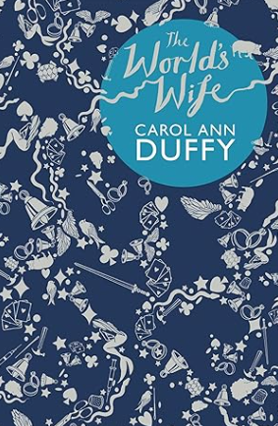
The World’s Wife is Carol Ann Duffy’s first themed collection of poems (published in 1999). The collection takes characters, stories, histories and myths which focus on men, and foregrounds the women who have previously been obscured behind the men.
The World’s Wife explores themes such as sexism, equality, bereavement and birth, and examines important historical events and stories through a feminist lens.

