Group: C06, C07, C08 |  |  | Subject: English | Term: 3
Teacher: |  | Helen Hawkins and Abi O’Brien
Curriculum: Secondary One Deepening
Term 3 focus:
HT1: Shakespeare – Romeo & Juliet
We will use the original text and film versions to help us understand and appreciate the plot and big ideas in the play. We will study selected extracts in more detail, focusing on Shakespeare’s use of language. We will learn how to write analytically about the play.
HT2: Poetry
We will study a range of poetry by different writers, learning about different poetic methods and forms. We will then write our own poetry.

Reading:
HT1: Understanding the text and using evidence
HT2: Enjoying the text

KO1 | Range of strategies used mostly effectively to read with fluency, understanding and expression
KO3 | Make inferences based on evidence from different points in the text, often correct
KO4 | Some structural choices identified with simple comment; identifies some basic organisational features
KO5 | Some basic language features identified; simple comments on writer’s choices
KO6 | Simple comment on overall effect on reader
KO7 | Simple comment identifies common features and effect that the reader’s or writer’s context has on the meaning
Writing:
HT1: Effective organisation of ideas and evidence
HT2: Writing poetry

KO1 | Relevant ideas and content chosen
KO2 | Main purpose and features clear; appropriate to purpose; style generally appropriate, some awareness of reader
KO3 | Ideas organised simply by clustering related points/ time sequence; sequencing generally logical; some signalling
KO5 | Some variety in length, structure or subject of sentences
KO7 | Some evidence of deliberate vocabulary choices; some expansion of general vocabulary to match topic

Tier Three Keywords:
Shakespeare | play | prologue | imagery | pun | Elizabethan
patriarchy | stanza | metaphor | onomatopoeia | alliteration | personification

Recommended Reading:
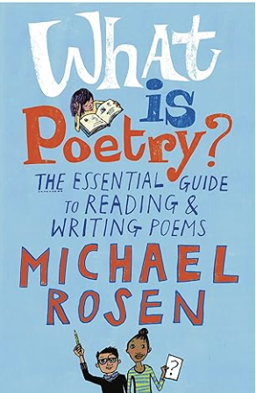
Over many years as a working poet, Michael Rosen has thought a great deal about what poems are, what they can do and the pleasure that comes from writing and reading poetry. In this invaluable handbook, he shares this knowledge and experience in book form for the very first time. Starting with a detailed analysis of a number of classic poems, he offers a real “writer’s guide” to writing and performing poems, as well as a wealth of technical information and tips. He then takes a fascinating look at a selection of his own poems and explains how and why he wrote them.

