Group: EW04 |  |  | Subject: English | Term: 3 | Step: 5
Teacher: |  | Angus Spencer
Curriculum: Study Programme Two Deepening
Term 3 focus:
HT5 – Exam Revision
HT6 – Poetry

Our third half term focuses on revision for the English Language GCSE and the English Functional Skills. As a class, we will be covering the skills of identify, evaluate, analysis and comparison. We will also be revising the written tasks of non-fiction and fiction writing. We will connect to the teaching of HT2 with the use of Victorian texts and HT3 with fiction writing.

We will study a range of poetry by different writers, learning about different poetic methods and forms. We will then write our own poetry, gaining influence and inspiration from the studied poems. This will introduce students to a variety of author backgrounds and styles of writing.

Reading:
HT1: Understanding the text and using evidence
HT2: Enjoying the text

KO3 | I infer meanings from varied evidence across the text. My comments develop explanations of these.
KO4 | I am aware that writers craft their writing by making structural choices. I identify and explain organisational features.
KO5 | I can identify language features which the writer has chosen to use and develop some explanation of them.
KO6 | I can clearly identify main purpose & perspectives. Have an overview of text. Can generally explain effect on reader.
KO7 | I can identify similarities, differences between texts with some explanation. Also how contexts contribute to meaning.
Writing:
HT1: Effective organisation of ideas and evidence
HT2: Writing poetry

KO1
KO2 | My purpose is clear and features of the form are adapted to the purpose. My appropriate style maintains the reader’s interest.
KO3 | I structure clearly within paragraphs. I develop material. I signal direction by links between paragraphs.
KO5 | I vary sentences for clarity, emphasis. Connectives relate ideas. Can structure for detail, nuance
KO7 | I use a fairly wide vocabulary, often appropriately and choose words for effect.

Tier Three Keywords:
infer | identify | audience | theme | survival
evaluate | purpose | present | setting | Analyse
context | character | malevolent | hierarchy | voice

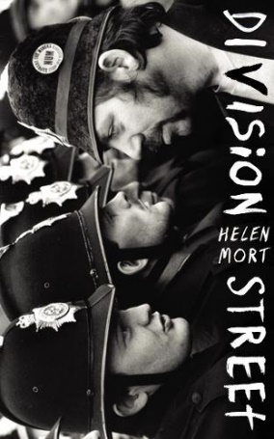

Division Street by Helen Mort
From the clash between striking miners and police to the delicate conflicts in personal relationships, Helen Mort's stunning debut is marked by distance and division. Named for a street in Sheffield, this is a collection that cherishes specificity: the particularity of names; the reflections the world throws back at us; the precise moment of a realisation.

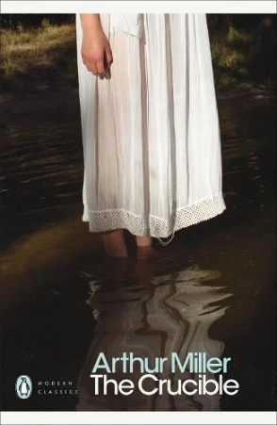

The Crucible by Arthur Miller
The Crucible follows the events of the Salem Witch Trials in Massachusetts, leading into themes of paranoia and suspicion which mirror the context of the Cold War and McCarthyism.

