Group: EW07 |  |  | Subject: English | Term: 3
Teacher: |  | Alex Bird
Curriculum: Higher Ready 3
Term 3 focus: GCSE revision and exam practice.
1 | Identify and interpret explicit and implicit information  and ideas
2 | Select and synthesise evidence from different texts
3 | Explain, comment on and analyse how writers use  language and structure to achieve effects and influence  readers, using relevant subject terminology to support  their views
4 | Compare writers’ ideas and perspectives, as well as how  these are conveyed, across two or more texts
5 | Evaluate texts critically and support this with appropriate  textual references
6 | Communicate clearly, effectively and imaginatively,  selecting and adapting tone, style and register for  different forms, purposes and audiences
7 | Organise information and ideas, using structural and  grammatical features to support coherence and  cohesion of texts
8 | Use a range of vocabulary and sentence  structures for clarity, purpose and effect, with accurate  spelling and punctuation
Tier Three Keywords:
Explicit | Implicit | Evidence | Analyse | Perspective | Evaluate
Structure | Purpose | Audience | Effect | Transactional
Recommended Reading:

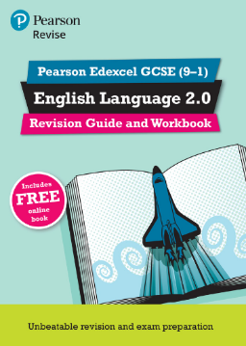
Pearson Edexcel GCSE (9-1) English Language 2.0

Revision Guide and Workbook

Contains both guidance for classroom and independent study,

and exam-style questions to help develop skills and

understanding of the assessment.

