Group: EW08 |  |  | Subject: English | Term: 3
Teacher: |  | Angus Spencer
Curriculum: Secondary Two Fundamental (Step 5)
Term 3 focus:
HT1: Shakespeare – Romeo and Juliet
We will use the original text and film versions to help us understand and appreciate the plot and big ideas in the play. We will study selected extracts in more detail, focusing on Shakespeare’s use of language. We will learn how to write analytically about the play.

HT2: Poetry
We will study a range of poetry by different writers, learning about different poetic methods and forms. We will then write our own poetry, gaining influence and inspiration from the studied poems. This will introduce students to a variety of author backgrounds and styles of writing.

Reading:
HT1: Understanding the text and using evidence
HT2: Enjoying the text

KO3 | I infer meanings from varied evidence across the text. My comments develop explanations of these.
KO4 | I am aware that writers craft their writing by making structural choices. I identify and explain organisational features.
KO5 | I can identify language features which the writer has chosen to use and develop some explanation of them.
KO6 | I can clearly identify main purpose & perspectives. Have an overview of text. Can generally explain effect on reader.
KO7 | I can identify similarities, differences between texts with some explanation. Also how contexts contribute to meaning.
Writing:
HT1: Effective organisation of ideas and evidence
HT2: Writing poetry

KO1
KO2 | My purpose is clear and features of the form are adapted to the purpose. My appropriate style maintains the reader’s interest.
KO3 | I structure clearly within paragraphs. I develop material. I signal direction by links between paragraphs.
KO5 | I vary sentences for clarity, emphasis. Connectives relate ideas. Can structure for detail, nuance
KO7 | I use a fairly wide vocabulary, often appropriately and choose words for effect.

Tier Three Keywords:
Shakespeare | play | prologue | imagery | pun | Elizabethan
patriarchy | stanza | metaphor | onomatopoeia | alliteration | personification

Recommended Reading:

Snap, Crackle and Bop is a poetry album by John Cooper Clarke using music to back his poems. This is a type of performance poetry and is intended to be read out loud. The poems focus on humour and comedic stories, but also have routes in poverty and addiction, aligning with Clarke’s personal values.
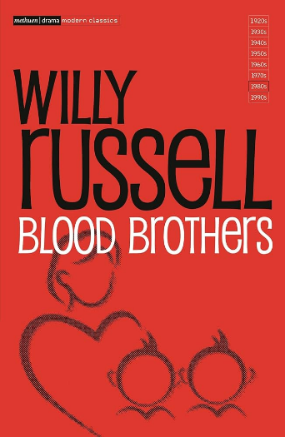
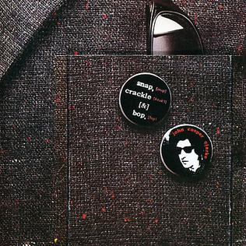

Blood Brothers by Willy Russell

The play focuses on two twins, separated at birth, one grew up in a poor household, one grew up in a rich household. Russell used music in the play to tell the story, demonstrating themes of class, depression and loyalty.

