Group: M01 |  |  | Subject: English | Term: 3
Teacher: |  | Natalie Wood
Curriculum: Secondary Ready Induction
Term 3 focus:
HT1: Shakespeare – A Midsummer Night’s Dream
We will use the original text and film versions to help us understand and appreciate the plot and big ideas in the play. We will study selected extracts in more detail, focusing on Shakespeare’s use of language. We will learn how to write analytically about the play.
HT2: Poetry
We will study a range of poetry by different writers, learning about different poetic methods and forms. We will then write our own poetry.

Reading:
HT1: Understanding the text and using evidence
HT2: Self-expression and enjoying the text
In some reading:
KO1 | Keywords read on sight; unfamiliar words decoded with strategies, e.g. blending; some fluency and expression
KO3 | Simple, plausible inference about events uses evidence; comments based on textual cues, sometimes understood
KO4 | Some awareness of use of features of organisation
KO5 | Some effective language choices noted, e.g. ‘slimy’ is a good word there; some familiar patterns identified
KO6 | Some awareness writers have viewpoints, purposes; simple statements on likes, dislikes, sometimes with reasons
KO7 | General features of a few text types identified; some awareness that books are set in different times and places
Writing:
HT1: Effective organisation of ideas and evidence
HT2: Writing Poetry
In some forms of writing:
KO1 | Relevant ideas and content chosen
KO2 | Some purpose established; some appropriate features used; some appropriate style
KO3 | Some sequencing of ideas or material; openings and/or closings sometimes signalled
KO5 | Sentences mainly simple; some variation in openings; “and” connects clauses; past, present generally consistent
KO7 | Straightforward, often speech-like vocabulary conveys relevant meanings; some adventurous word choices
Tier Three Keywords:

Shakespeare | play | tragedy | imagery | meter | Jacobean
patriarchy | stanza | metaphor | onomatopoeia | alliteration | personification

Recommended Reading:

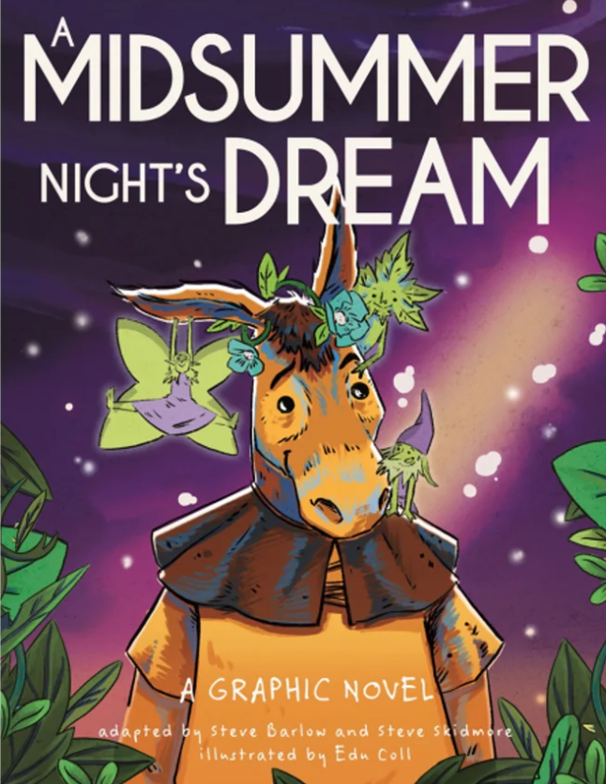
– snappy simplified text presenting Shakespeare’s themes clearly
– introductory materials to help set the scene and context of each story
– heaps of extra material at the back to keep the learning and fun going, including an exploration of themes in the play, the language, Shakespeare’s inspirations, the publication and performance of the play in history, a timeline of Shakespeare’s life and works, and much more!

