Group:M03 |  |  | Subject: English | Term: 3
Teacher: |  | Matt Hall and Chelsea Mellor
Curriculum: Secondary One Fundamentals
Term 1 focus:
HT1 - Shakespeare – Twelfth Night
In our Shakespeare half term, we will be reading Twelfth Night. We will use different strategies to help understand and enjoy the play, with a focus on interpretation of ideas and how these ideas were shaped by the historical period and may be understood differently today. We will look closely at how different characters’ language use expresses love at various points, and how gender is played with in the story. As well as reading extracts in class, we will also watch different performances to see how it can be staged and to help the students understand it as a play.
HT2 – Poetry
Our poetry half term to finish the year is always focused principally on enjoyment of poetry and language, with students given equal opportunity to write poems as read them, and experiment with rhythm and figurative language to express themselves in different ways. We will focus on a different style of poem/s each week and then use this as a start point for our own writing.

Reading:
HT5: Understanding the text and using evidence
HT2: Enjoying the text

KO1 | Range of strategies used mostly effectively to read with fluency, understanding and expression
KO3 | I make straightforward inferences based on clues. I know the main meaning. I can speculate about things in the text
KO4 | I can identify several organisational features of texts.
KO5 | I can identify some language features which the writer has chosen to use.
KO6 | I can identify author’s main purpose, express personal response, notice perspectives & effects of language choices.
KO7 | I can identify some simple connections between texts. I recognise some features of the context of texts.
Writing:
HT1: Effective organisation of ideas and evidence
HT2: Writing poetry

KO1 | I can introduce some appropriate ideas and elaborate on them. I try to write from a viewpoint.
KO2 | I try to place related points near each other & signal openings & closings. Some logical sequencing
KO3 | I can use simple, generally appropriate vocabulary. Some words selected for effect or occasion.
KO5 | I use simple sentence structures, varied with support. Common connectives. More tense, verb forms.
KO7 | I can use simple, generally appropriate vocabulary. Some words selected for effect or occasion.

Tier Three Keywords:
infer | identify | structure | plot | character | scene
playwright | Elizabethan | Iambic pentameter | verse | meter | gender
Elizabethan | metaphor | imagery | stanza

Recommended Reading:

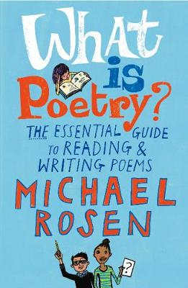
Over many years as a working poet, Michael Rosen has thought a great deal about what poems are, what they can do and the pleasure that comes from writing and reading poetry. In this invaluable handbook, he shares this knowledge and experience in book form for the very first time. Starting with a detailed analysis of a number of classic poems, he offers a real “writer’s guide” to writing and performing poems, as well as a wealth of technical information and tips. He then takes a fascinating look at a selection of his own poems and explains how and why he wrote them.

