Group: M01 |  | Subject: Mathematics | Term: 3
Teacher: | Natalie Wood and Ross Graham
Curriculum: Secondary Ready: Fundamentals
Term 3 focus: We will explore fractions as parts of one whole; parts of a whole as many; a number in relation to other numbers; and the functional relationship between two objects. It follows the previous terms work as fractions are underpinned by multiplicative relationships. Students will develop their understanding of fractions, building on their' knowledge multiplicative relationships. The structures, rather than the solutions, will remain the focus throughout.
 | Theme | Objective | Attendance | How I felt about it  
 |  |  | (Date unit finished) | End of  unit | 4 weeks later | End of term
1 | Theme 1 | I understand unit fractions as division of a whole into equal parts, including where parts are equal but not congruent.
2 | Theme 1 | I understand the denominator of the fraction indicates the size of the equal parts in the fraction.
3 | Theme 1 | I understand the numerator of the fraction indicates the number of equal parts in the fraction.
4 | Theme 1 | I understand all unit and non-unit fractions are numbers than can be placed on a number line.
5 | Theme 1 | I understand how denominators can be used to compare fractions.
6 | Theme 1 | I understand how numerators can be used to compare fractions.
7 | Theme 1 | I understand how fractions can be compared when they don’t have a common numerator or denominator.
8 | Theme 1 | I am able to recognise equivalent fractions below and beyond 1.
9 | Theme 1 | I can represent tenths and hundredths as decimals and fractions.
10 | Theme 1 | I am able to find a fraction of an amount.

Tier Three Keywords:
Whole | Part | Numerator | Denominator | Divisor
Dividend | Division | Equal | Congruent | Accuracy

Assessment:
Daily Assessment | Substantive Assessment
Type:  Formative assessment happens throughout mathematics lessons, questioning during modelling, encouraging students to explain and justify their working as well as checking work completed. | Type:  During recall lessons objectives will be assessed around 4 weeks after they have been taught in the form of low stakes tasks. Students will have the opportunity to show they are secure in their understanding. Where students are not yet secure, they will be given scaffolding and opportunities to show they are embedding, developing or beginning to use this knowledge.  Students will also attempt problem-solving tasks during recall lessons which give opportunities for them to apply their mathematics to a variety of routine and non-routine problems, giving them an opportunity to show their reasoning and problem-solving skills.

Recommended Reading:

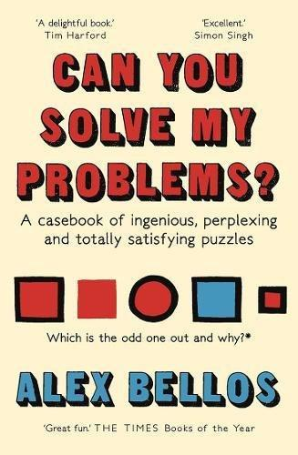
Can You Solve My Problems? – Alex Bellos
This book contains 125 of the world's best brainteasers from the last two millennia, taking us from ancient China to medieval Europe, Victorian England to modern-day Japan, with stories of espionage, mathematical breakthroughs and puzzling rivalries along the way. Some solutions rely on a touch of cunning, others call for creativity, others need mercilessly logical thought. All are guaranteed to sharpen your mind!

Further resources:
Practice skills:
https://www.mathsgenie.co.uk/
https://www.mathslinks.co.uk/
https://corbettmaths.com/contents/
https://diagnosticquestions.com/

Problem solving:
https://nrich.maths.org/secondary-live-problems-and-recent-solutions
https://www.youcubed.org/tasks/
https://ukmt.org.uk/puzzles
https://www.cut-the-knot.org/
https://www.transum.org/Software/Puzzles/
https://www.mathsisfun.com/puzzles/index.html

