Group:  M01 |  | Subject:  PSHE | Term: 3
Teacher: | Natalie Wood
Curriculum: Secondary Ready
Term focus: Consent and attraction; Managing risk around water, gangs and weapons. By the end of the topic students will be able to recognise the legal framework for consent, and give examples of how to seek and give consent. They will be aware that pressure, coercion and manipulation do not lead to enthusiastic consent. Students will develop skills in managing and dealing with peer pressure and resisting harmful influence. Students will improve their skills in staying safe in the community, including around bodies of water.

1 | The qualities and behaviours they should expect, and exhibit, in a wide variety of positive relationships (in school and society, Family and friendships, including online)
2 | To manage the strong feelings that relationships can cause (including sexual attraction)
3 | That consent is freely given, that being pressurised, manipulated or coerced into something is not giving consent, and how to seek help in such circumstances
4 | About the law relating to sexual consent
5 | How to seek, give, not give, and withdraw consent (in all contexts, including online)
6 | That the seeker of consent is legally and morally responsible for ensuring that consent has been given, that if consent is not given, or withdrawn, that decision should always be respected)
7 | To recognise peer influence and to develop strategies for managing it, including online
8 | The role peers can play in supporting one another to resist pressure and influence, challenging harmful social norms and access appropriate support
9 | That the need for peer approval can generate feelings of pressure and lead to increased risk taking; strategies to manage this
10 | Strategies to remain safe in the community, specifically around bodies of water
11 | About the factors that contribute to young people joining gangs; the social legal and physical consequences of gang behaviour
12 | Strategies to manage pressure to join a gang, exit strategies and how to access appropriate support
13 | Motivations, misconceptions and consequences of carrying weapons, and strategies for managing pressure to carry a weapon.

Tier Three Keywords:
Attraction | Consent | Pressure | Manipulation | Coercion | Informed consent
Morally | Legal | Respect | Peer influence | Approval | Risk taking
Strategies | Weapons | Support

Recommended Reading:

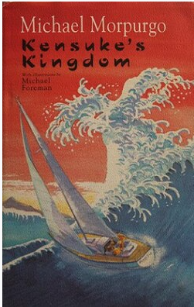
Kensuke's Kingdom by Michael Morpurgo

tells the story of an eleven-year Michael, whose family decides to sail around the world after his parents are made redundant from the local brickworks. The family set off with their dog, Stella Artois. On one deceptively calm night, the family dog Stella Artois appears on deck, and given that she had previously fallen overboard in the Indian Ocean, Michael tries to retrieve her. A sudden wind takes hold of the yacht, and both Michael and Stella are washed overboard.

Alone and clinging to a football for buoyancy, Michael is convinced he will drown. Yet the next morning he finds himself on the shore of a peanut-shaped island with Stella, both alive and well. Questions as to how he came to be on the island are soon replaced by how they are to survive, and despite a thorough search of their new home, Michael and Stella are unable to find any food or fresh water. They are saved once again however, when they find that someone (or something) has left them water and food near the cave where they are sheltering.

