Group: M05 |  | Subject:  PSHE | Term: 3
Teacher: | Liz Lynch-Smith & Luke Knowles
Curriculum: Secondary 1 exploring
Term focus: Consent and changing relationships; financial choices. Students will learn that everyone has choice over when they have sex and that intimacy should be pleasurable. They will develop skills to reduce risk both online and offline, and learn how to manage the end of a relationship, as well as other life changes such as bereavement, divorce or separation. Students will review their values and attitudes to money and saving, and recognise financial exploitation.
1 | that everyone has the choice to delay sex, or to enjoy intimacy without sex
2 | to gauge readiness for sexual intimacy
3 | that intimate relationships should be pleasurable
4 | Strategies to identify and reduce risk from people online that they do not already know; when and how to access help
5 | To manage the influence of drugs and alcohol on decision making within relationships and social situations
6 | How to manage the breakdown of a relationship (including it's digital legacy) loss and change in relationships
7 | The effects of change, including loss, separation, divorce and bereavement; strategies for managing these and accessing support
8 | Services available to support healthy relationships and manage unhealthy relationships and how to access them
9 | to assess and manage risk in relation to financial decisions that young people might make
10 | about values and attitudes relating to finance, including debt
11 | to manage emotions in relation to money
12 | to evaluate social and moral dilemmas about the use of money, including the influence of advertising and peers on financial decisions
13 | to recognise financial exploitation in different contexts eg drug and money mules, online scams

Tier Three Keywords:
Intimacy | Readiness | Pleasurable | Sex | Influence | Drugs
Alcohol | Breakdown | Digital legacy | Bereavement | Financial decisions | Risk and reward
Financial exploitation | Drug mules | Money mules

Recommended Reading:

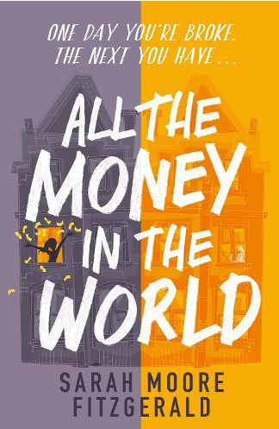
All the Money in the World by Sarah Moore Fitzgerald

Fifteen-year-old Penny longs for something better. Better than a small, damp flat. Better than her bullying classmates and uninterested teachers. Better than misery and poverty day in day out.

An unlikely friendship and a huge sum of money promise a whole lot of new chances for Penny, and she realises that not only can she change her life, she can change herself.

But at what cost?

