Group: EW03 |  | Subject: Mathematics | Term: 3
Teacher: | Mike Gouldin & Ross Graham
Curriculum: Secondary Two: Exploring
Term 3 focus: This term will first cover the data handling cycle in statistics; representing and analysing data. We will then look at non calculator methods for calculations with directed numbers, decimals and fractions. We will move on to looking at sequences, standard form and manipulating expressions.
 | Theme | Objective | Attendance | How I felt about it  
 |  |  | (Date unit finished) | End of  unit | 4 weeks later | End of term
1 | Theme 5 | I am able to draw and interpret graphs and diagrams
2 | Theme 5 | I can find and interpret averages
3 | Theme 2 | I can efficiently use all 4 operations without a calculator
4 | Theme 1 | I can round to a given level of accuracy
5 | Theme 1 | I can find the HCF and LCM of a given pair of numbers
6 | Theme 4 | I can find and use the nth term rule of a linear sequence
7 | Theme 1 | I understand and can apply the rules of indices
8 | Theme 2 | I can calculate with numbers in standard form
9 | Theme 1 | I can simplify algebraic expression
10 | Theme 1 | I can form and solve equations and inequalities with fractions

Tier Three Keywords:
Scatter Graph | Cumulative Frequency | Box Plot | Mean | Median
Mode | Arithmetic | Geometric | Indices | Expression

Assessment:
Daily Assessment | Substantive Assessment
Type:  Formative assessment happens throughout mathematics lessons, questioning during modelling, encouraging students to explain and justify their working as well as checking work completed. | Type:  During recall lessons objectives will be assessed around 4 weeks after they have been taught in the form of low stakes tasks. Students will have the opportunity to show they are secure in their understanding. Where students are not yet secure, they will be given scaffolding and opportunities to show they are embedding, developing or beginning to use this knowledge.  Students will also attempt problem-solving tasks during recall lessons which give opportunities for them to apply their mathematics to a variety of routine and non-routine problems, giving them an opportunity to show their reasoning and problem-solving skills.

Recommended Reading:
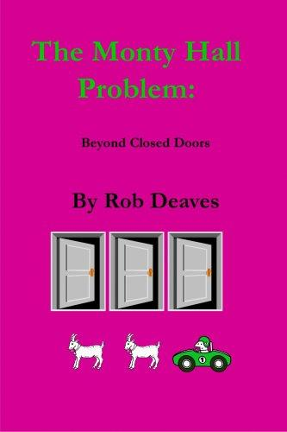

The Monty Hall Problem: Beyond Closed Doors – Rob Deaves
This short book explores the Monty Hall dilemma, a well known mathematical puzzle. The original problem, the controversy surrounding it and its solution are discussed. Further, the boundaries of the problem are expanded to consider prior knowledge and host intention. This book should be of interest to those who enjoy problem solving.

Further resources:
Practice skills:
https://www.mathsgenie.co.uk/
https://www.mathslinks.co.uk/
https://corbettmaths.com/contents/
https://diagnosticquestions.com/

Problem solving:
https://nrich.maths.org/secondary-live-problems-and-recent-solutions
https://www.youcubed.org/tasks/
https://ukmt.org.uk/puzzles
https://www.cut-the-knot.org/
https://www.transum.org/Software/Puzzles/
https://www.mathsisfun.com/puzzles/index.html

