Group: BR11,BR12,BR13,BR14,BR15, EW05, EW06 |  | Subject: PEA | Half-Terms: 5
Teacher: Liz Lynch Smith, Milly Latham, Amanda Grego, Nayna Kennedy, Becky Wilcox, Rebecca Scott
Curriculum: Study Programme
Term focus: Considering the future
End Point: Students will be able to research and compare post-16/post-Y12 pathways, understand local and personal factors that influence choices, and create a realistic, flexible action plan that reflects their skills, interests, and circumstances.
Post-Y12 options | Selects useful sources of information about post-Y12 pathways  Compares pros and cons of full-time education, employment, and apprenticeships  Analyses scenarios of young people deciding on their post-16 pathway  Ranks post-Y12 pathways in order of current preference
Decision making - choosing your post-Y12 program | Understands the local offer in Sheffield and can discern which is the best for them.
Money talks: apprenticeships vs. higher education | Understands pros and cons of apprenticeships  Understands pros and cons of higher education  Explains how factors such as someone’s financial situation could impact their career pathway choices
Exploring other interests - Enrichment opportunities and community involvement | Y11-13 select appropriate enrichment options to suit their own interests and those of their group.

Group: BR11,BR12,BR13,BR14,BR15, EW05, EW06 |  | Subject: PEA | Half-Terms: 6
Teacher: Liz Lynch Smith, Milly Latham, Amanda Grego, Nayna Kennedy, Becky Wilcox, Rebecca Scott
Curriculum: Study Programme
Term focus: Independent Travel
End point: Students will be able to research and compare post-16/post-Y12 pathways, understand local and personal factors that influence choices, and create a realistic, flexible action plan that reflects their skills, interests, and circumstances.
Creating a plan to travel on public transport independently | Develop practical journey-planning skills, public transport knowledge, and confidence to travel independently by safely navigating routes, timetables, tickets, and real-time travel information
Carrying out a plan to travel on public transport independently | Develop the skills, confidence, and practical experience needed to independently complete a planned public transport journey by following routes, managing tickets, adapting to changes, and travelling safely.
Incorporating a combination of walking with either tram/train/bus to reach a destination with minimal support or complete autonomy | Understanding how to follow a route to and from the pick up and drop off point of public transport to complete a journey safely and with minimal support or full autonomy
Using a map to plan a walk off-road | Develop map-reading, route-planning, navigation, and environmental awareness skills needed to safely plan and follow an off-road walking route.
Carrying out a walk off-road | Understanding of how to follow a pre-planned route using map skills and pre-taught knowledge of the area they will walk
Incorporating a combination of walking with either tram/train/bus to reach a destination with minimal support or complete autonomy | Combined knowledge and skills learnt throughout this half term will culminate in an opportunity to travel independently, where appropriate.

Keywords:
Employment | Apprenticeship | Further Education | Higher Education | Contingency
Timetable | Destination | Autonomy | Navigation | Route planning

Recommended Materials:
Travel planning resources:
https://journeyplanner.travelsouthyorkshire.com/
https://www.google.com/maps
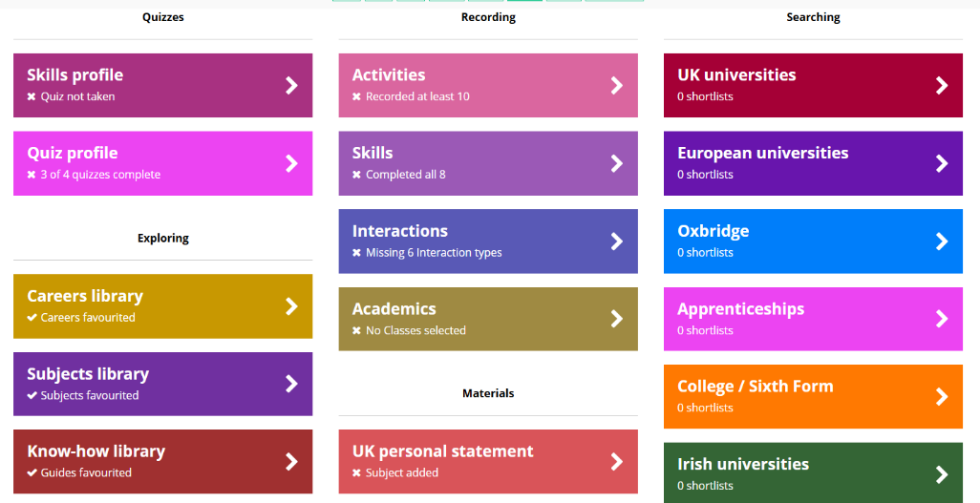
Unifrog resources including careers library, MOOCs and Know-how library



