Group: M01 |  | Subject: PEA | Half Term: 5
Teacher: Steph Kirton
Curriculum: Sec Ready Fundamentals
Term focus: Healthy Lifestyles

End Point: The learner understands the importance of exercise and healthy leisure activities, participates in a range of activities, plans and teaches one to others, and engages respectfully and responsively within social leisure settings.
Recognises the importance of exercise as a leisure | Identifies the different benefits of exercise. Explores other things that benefit mental and physical health. What are the different benefits of individual sports v team sports?
Develop an understanding of what activities are available to develop a healthy lifestyle | Identifies different types of leisure activity. Expresses preferences for specific leisure activities. Demonstrates consistent interest in preferred leisure activities.
Learn to have a go and participate in various leisure activities | Tries different leisure activities with encouragement. Participates in leisure activities with peers or family members. Independently engages in chosen leisure activities.
Plans own leisure activity and prepares to teach it to others | Understands the concept of planning a leisure activity. Helps plan simple leisure activities (e.g., choosing a game or a craft project). Independently plan and organises a leisure activity. Recognises the needs and feelings of others during leisure activities.
Learns to respectfully engage in social exchange within leisure activity and takes account of others. | Learns basic social skills like sharing and taking turns during leisure activities. Participates in group leisure activities, practicing effective communication. Demonstrates the ability to engage in meaningful social exchanges during leisure activities, practices empathy and cooperation. Shows consideration and inclusivity during leisure activities.
Accepts and applies guidance within leisure activity | Understands and follow simple instructions during leisure activities. Accepts and applies guidance from peers or adults during activities. Demonstrates the ability to seek and applies feedback (eg two stars and a wish) to improve participation in leisure activities.

Group: M01 |  | Subject: PEA | Half Term: 6
Teacher: Steph Kirton
Curriculum: Sec Ready Fundamentals
Term focus: Working with others

End Point: The learner develops an understanding of community and the needs within it, including the groups that work locally to meet those needs. They learn about one community group in depth and consider ways they could support that group or another.

Explores what community means and what communities we belong to. | Students learn what a community is and recognise different communities they belong to, such as family, school, and local groups. They develop skills in identifying, describing, and reflecting on their sense of belonging.
Explores the needs of a community | Students learn about different needs within a community, such as support, safety, and wellbeing. They develop skills in recognising community challenges and discussing why meeting these needs is important.
Learns what groups are available locally to meet local needs | Students gain knowledge of local organisations and groups that help meet community needs. They develop research and communication skills by identifying and sharing information about these groups.
Learns about the work of one local community group | Students learn about the purpose and activities of a specific local community group. They develop investigation and presentation skills while understanding the impact of community support.
Considers how they may wish to support that group or another | Students learn about ways people can support community groups, such as volunteering or fundraising. They develop decision making skills by considering how they could contribute to their community.

Keywords:
Community | Volunteering | Fundraising | Organisations | Community
Wellbeing | Decision making | Participate | Leisure

Recommended Reading:
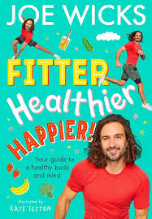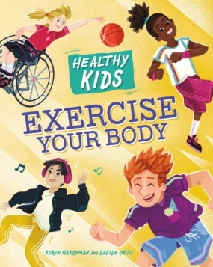

Books about young people and their communities


