Groups: C06, C07 & C08 |  |  | Subject: Drama and Oracy | Term: 3
Teacher: |  | Lizzie
Curriculum: Deepening KS3.
Term 3 focus: Interview Skills, Court Room Dramas and Mock Trials.
1 | Join in with activities to develop confidence and deepen understanding of performance techniques
2 | Understand and apply vocal and physical skills to create a character or presentation
3 | Demonstrate reciprocal working in a pair or group
4 | Show understanding of confidence through body language and vocal expression
5 | Explore the roles and responsibilities in a courtroom and how juries decide on their verdict
6 | Understand the difficulties of eye witness testimonies and cross examinations
7 | Give positive and constructive feedback to support peers during the development and performance process
8 | Show understanding through answering questions and partaking in group discussions
9 | Create a Mock Trial using courtroom terminology and responsibilities
10 | Answer questions in an interview styled assessment

Tier Three Keywords:
Vocal | Physical | Script | Expression | Setting | Evidence
Perform | Confidence | Body Language | Given Circumstance | Character | Audience
Direct | Contrast | Presentational | Intonation | Context | Monologue

Recommended Reading (and watching):

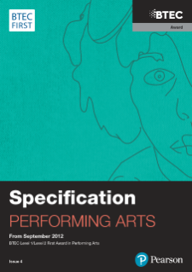 BTEC First Award in Performing Arts Specification

