Group: M03 |  |  | Subject: Drama & Oracy | Term: 3
Teacher: |  | Lizzie Bloor
Curriculum: Secondary One Fundamentals
Term 3 focus: Introduction to Devising Drama
Roles and Responsibilities in the theatre
1 | Join in with activities, discussions and games to develop confidence
2 | Create a performance based off a stimulus
3 | Develop devised performances using Drama techniques
4 | Use Improvisational skills to develop scenes within a performance
5 | Understand the importance of vocal and physical skills in both Drama and Oracy and know how they are used
6 | Demonstrate reciprocal working in a pair or group
7 | Show applied work to peers via performance or presentation
8 | Develop understanding of Roles and Responsibilities in the theatre by becoming one and applying their role practically.
9 | Apply vocal and physical skills when performing or presenting to show confidence or character

Tier Three Keywords:
Speech | Designer | Explorative | Presentational | Stage | Confidence
Perform | Manager | Volume | Technician | Costume | Audience
Tone | Expression | Physical | Stimulus | Devise | Vocal

Recommended Reading (and watching):

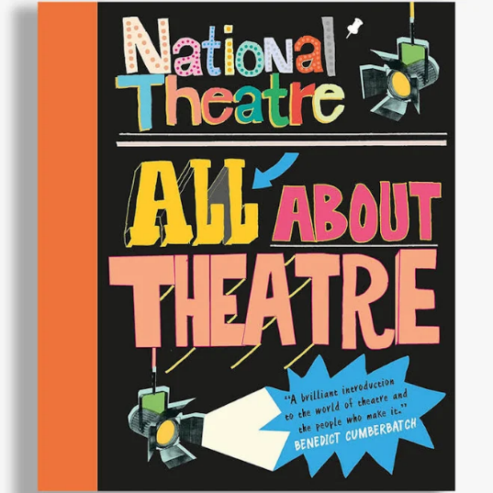
Roles and Responsibilities
within the theatre,
from front of house to back stage.

