Group: M04 & M05 |  |  | Subject: Drama and Oracy | Term: 3
Teacher: |  | Lizzie
Curriculum: Exploring KS3.
Term 3 focus: Filming
1 | Join in with activities and games to develop confidence
2 | Understand and apply vocal and physical skills to create a character
3 | Demonstrate reciprocal working in a group
4 | Show applied work to peers via performance
5 | Show understanding of Clapper Board and other filming equipment
6 | Take a director’s role within the filming process to develop leadership skills
7 | Give positive and constructive feedback to support peers during practical assessments
8 | Use editing software to create your final film
9 | Incorporate multiple shots and angles while paying attention to continuity errors
10 | Stay in character throughout performances

Tier Three Keywords:
Micro- acting | Editing | Action | Clapperboard | Reaction | Shot
Perform | Naturalism | Continuity | Blocking | Character | Audience
Film | Expression | Intonation | Body Language | Explorative | Angle

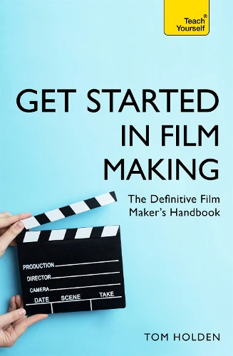
Recommended Reading (and watching):

Get Started in Film Making by Tom Holden

Get Started in Film Making is the essential guide for all budding film makers, empowering and inspiring anyone to unleash their creative side. Completely revised and updated, it is the perfect manual for smartphone Spielbergs, Go-Pro adrenaline junkies, drone-warriors, and wannabe vloggers. It covers every aspect of making films, showing you what's involved from start to finish. You won't get bogged down with technical jargon or confusing proprietary expressions. Instead it breaks things down into easy, step-by-step stages, emphasising that creativity, enthusiasm and drive are just as important as cool kit and funky editing apps. From scriptwriting, casting and cameras to lighting, financing, filming and editing, this is the most comprehensive, user-friendly guide on the market.

