Group: GCSE Y1 |  |  | Subject: Music | Term: 3
Teacher: |  | Rae
Curriculum: Secondary 2 Exploring
A0S4: Western Classical Tradition from 1910:
Western classical tradition since 1910 is defined as music that comprises modern, contemporary classical music, experimental and minimalist music as well as other forms.
Students will be able to listen attentively to unfamiliar music from the following styles/genres to identify and accurately describe musical elements, musical contexts and musical language:
• The orchestral music of Copland
• British music of Arnold, Britten, Maxwell-Davies and Tavener
• The orchestral music of Zoltán Kodály and Béla Bartók
• Minimalist music of John Adams, Steve Reich and Terry Riley.

Set Works AOS1-4:
Students will develop a good knowledge and understanding of the musical features of the following set works and gain confidence writing critically about these pieces:

AOS1: Western Classical Tradition 1650-1910
Beethoven: Symphony No.1, Movement 1: Adagio molto – Allegro con brio

AOS2: Popular Music
Queen – the following three tracks:
- Bohemian Rhapsody
- The Seven Seas of Rhye
- Love of my Life

AOS3: Traditional Music
Esperanza Spalding – the following three tracks:
- Little Fly
- I Know You Know
- I Adore You

AOS4: Western Classical Tradition from 1910
Béla Bartók – ‘Magyar Kepek, Hungarian Sketches’ – the following four movements:
- ‘Este A Svékelyeknél – An Evening in the Village’
- ‘Medvetánc – Bear Dance’
- ‘Kicsit Ázottan – Slighty Tipsy’
- ‘Ürögi Kanásztánc – Swineherd’s Dance’
*Note that Movement 3 is not a set work.

1 | Identify and accurately describe musical elements, contexts and language of the orchestral music of Copland
2 | Identify and accurately describe musical elements, contexts and language of British music of Arnold, Britten, Maxwell-Davies and Tavener
3 | Identify and accurately describe musical elements, contexts and language of the orchestral music of Kodály and Bartók
4 | Identify and accurately describe musical elements, contexts and language of Minimalist music of Adams, Reich and Riley
5 | Develop a good knowledge and understanding of the musical features of Symphony No.1, Movement 1: Adagio molto – Allegro con brio by Beethoven
6 | Develop a good knowledge and understanding of the musical features of ‘Bohemian Rhapsody’, ‘The Seven Seas of Rhye’ and ‘Love of my Life’ by Queen
7 | Develop a good knowledge and understanding of the musical features of ‘Little Fly’, ‘I Know You Know’ and ‘I adore you’ by Esperanza Spalding
8 | Develop a good knowledge and understanding of the musical features of movements 1, 2, 4 and 5 of ‘Magyar Kepek, Hungarian Sketches’ by Bartók
9 | Confidently answer extended writing questions about the set works for AOS1-4 using correct musical vocabulary
10 | Confidently write critically about both familiar and unfamiliar music using correct musical vocabulary.

Tier Three Keywords:
Dynamics | Rhythm | Structure | Metre | Melody | Instrumentation
Texture | Timbre | Tonality | Tempo | Harmony | minimalism
Neoclassicism | dissonance | Miasma | Exposition | Development | Recapitulation
Half Term 1 Assessment
Daily Assessment | Substantive Assessment
- Active listening activities  - Class discussions  - Building a portfolio of composition ideas  - Starter recall questions | - Exam style listening activities  - Practice exam style written questions

Half Term 2 Assessment
Daily Assessment | Substantive Assessment
- Active listening activities  - Class discussions  - Building a portfolio of composition ideas  Starter recall questions | - Exam style listening activities  Practice exam style written questions

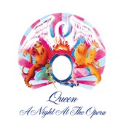
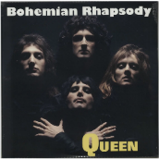
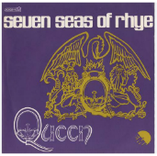
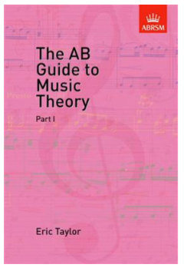
Recommended Reading (and Listening):

The AB Guide to Music Theory Part I by Eric Taylor

Provides an introduction to the basic elements in harmony and musical structure. Covers the basics of rhythm and tempo, an introduction to pitch, intervals and transposition, articulation, ornaments, and reiterations.

Beethoven:

Symphony No.1, Movement 1: Adagio molto – Allegro con brio was dedicated to Baron Gottfried van Swieten, an early patron of the composer. The piece was published in 1801 by Hoffmeister & Kühnel of Leipzig. It is not known exactly when Beethoven finished writing this work, but sketches of the finale were found to be from 1795.

Queen:

Bohemian Rhapsody is a song by the British rock band Queen, released as the lead single from their fourth studio album, A Night at the Opera (1975).

The Seven Seas of Rhye was first introduced as a short, rudimentary instrumental version, tucked away at the end of the group's debut album Queen (1973). Later we got a fully realised, definitive version on Queen II (1974).

Love of My Life is a song from the 1975 album A Night at the Opera.

Esperanza Spalding:

Esperanza Spalding is an award-winning American jazz singer, bassist and composer. She is known for her fusion style. This is when two or more styles, or traditions, are mixed together.

In Little Fly, Spalding creates music that combines western classical music with jazz.

I Know You Know features on her album Esperanza. Spalding performed this song in 2009 at the concert to celebrate Barack Obama receiving the Nobel Peace Prize.

In I Adore You, Spalding creates music that combines jazz with the Latin style of samba, as well as elements of Afro Cuban music.

Bartók:

‘Magyar Kepek, Hungarian Sketches’ is a suite for orchestra by Hungarian composer Béla Bartók finished in 1931. The suite consists of orchestrations of earlier short pieces for piano composed between 1908 and 1911



