Group: C08 |  |  | Subject: Arts | Term: 3
Teacher: |  | Kate
Curriculum: Secondary One Deepening
Term focus: Arts Award
This term our focus will continue to be working towards the Bronze Arts Award which is a nationally recognised, Level 1 qualification. The award is a flexible and personalised learning programme designed to inspire learners to grow their creative and leadership talents. Participants explore their individual interests in any art form (from drawing and painting to music, drama, digital art or poetry) and record their experiences in an individual arts portfolio.

To achieve the Bronze Arts Award, students must gather evidence in their portfolio across four main areas:
- Part A: Active Participation in the Arts
- Part B: Arts Event Experience and Review: There will be an opportunity to participate in a group trip to support this aspect.
- Part C: Arts Inspiration Research
- Part D: Sharing Arts Skills

1 | I can record and present my evidence in a creative and visually engaging way that others can understand.​
2 | I can choose an art form and set a personal creative goal.​
3 | I can develop my artistic skills while working towards my goal.​
4 | I can explain what I have learnt and how my interests, knowledge, and skills have developed.​
5 | I can take part in a visit to a creative arts space or attend a live arts event.​
6 | I can describe the arts event and give my opinion on its quality and impact.​
7 | I can share my thoughts and reflections about the arts event with others.​
8 | I can lead an arts skills activity by planning, guiding, and supporting others while sharing my arts skills.​
9 | I can reflect on how well I led the activity and what I would improve next time.
10 | I can communicate my ideas clearly when leading an activity, using appropriate language, demonstrations, and examples to support others’ understanding.
Tier Three
Keywords:
Inspiration | Impact | Influence | Evaluate | Context | Critique
Respond | Present | Public Art | Sculpture

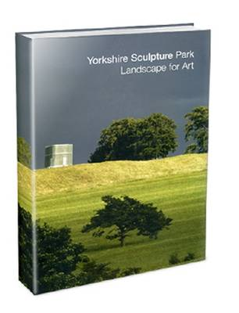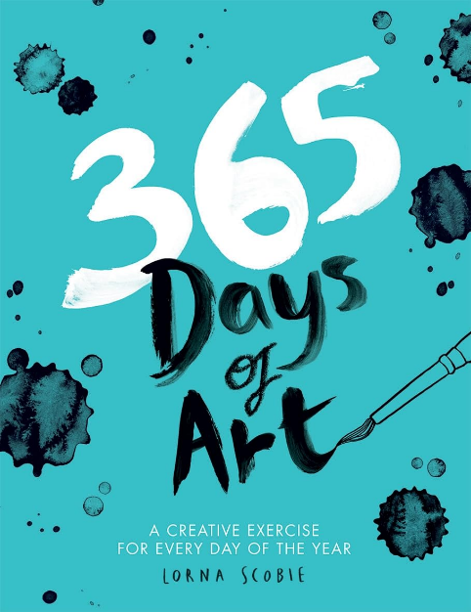
Recommended Reading:

