Group: GCSE Art S2E |  | Subject: Art | Term: 3
Teacher: | Molly Meyrick/Kizzy Jaycock
Curriculum: S2 Exploring
Term 3 focus:
Starting point theme: ‘Messages’.

Students will explore identity, communication, and personal meaning through 3D form and surface, researching artists such as Barbara Hepworth, Grayson Perry and Louise Bourgeois

Students will respond to the theme ‘Messages’, participating in sculpture workshops using clay, wire, papier-maché, and mixed media. Students will develop ideas in their sketchbooks, experimenting with mark-making, texture, and pattern to inform their final sculptural response.

Assessment Objectives:
- AO1: Develop ideas and show critical understanding of artists.
- AO2: Refine work through material and surface experimentation.
- AO3: Record observations and insights in sketchbooks and maquettes.
- AO4: Produce a personal, meaningful sculpture demonstrating skill and creativity.
 | Learning Objective | Assessment   | Daily feedback
1 | Develop a series of observational drawings focusing on texture, pattern, and surface from objects or personal surroundings. - AO3 |  | - Verbal feedback during live drawings.  - Whole class feedback addressing common strengths and misconceptions.  - Written sketchbook comments where needed (post it notes).
  Formative assessment
  Next steps…
2 | Research and analyse artists and sculptors who communicate messages through form and surface, annotating findings in sketchbooks. -AO1 |  | - Written feedback on annotated artist research.  - Use of a checklist to support self-assessment and improve depth of analysis.
  Formative assessment
  Next steps…
3 | Experiment with different sculptural materials (clay, wire, papier-maché and mixed media) and surface techniques to test ideas. -AO2 |  | - Verbal feedback during practical experimentation.  - Peer feedback through discussion and sharing of outcomes.  - Verbal feedback to encourage refinement and risk-taking.
  Formative assessment
  Next steps…
4 | Produce a series of thumbnail sketches and maquettes to refine ideas. - AO2 |  | - Verbal feedback focused on refinement and decision-making.  - Use of a checklist to support self-assessment against success criteria.  - Written feedback to guide next steps.
  Formative assessment
  Next steps…
5 | Explore mark-making, texture, and pattern in 2D and 3D formats to develop visual language for the final piece. - AO2 |  | - Verbal feedback to support development of visual language.  - Use of a checklist to support self-assessment and so that students evaluate experimentation and progress.
  Formative assessment
  Next steps…
6 | Select and justify a final idea for a personal sculptural piece through written annotation and visual plans, informed by observations from a visit to Yorkshire Sculpture Park. - AO3 |  | - Written feedback on visual plans and written justification.  - Verbal feedback through 1:1 and whole class discussions.  - Use of a checklist to support self-assessment and clarity of decision-making.
  Formative assessment
  Next steps…
7 | Apply knowledge of surface, form, and texture to produce a sculptural outcome that communicates a personal message. - AO4 |  | - Verbal feedback throughout the making process.  - Written feedback focused on improving craftsmanship, surface quality and communication of meaning through questioning and prompts- how/ why/ I wonder if...  - Whole-class feedback to reflect and address common issues and strengths.
  Formative assessment
  Next steps…
8 | Reflect on progress throughout the project, evaluating the success of techniques, materials, and personal expression. - AO3 |  | - Self-assessment through written reflection.  - Use of a checklist to support reflective thinking and identification of strengths and areas for development.  - Written feedback on evaluation.
  Formative assessment
  Next steps…
9 | Present the final sculpture. - AO4 |  | - Verbal feedback to final presentation  - Peer/ whole-class feedback focused on interpretation and communication of meaning linked to assessment criteria.
  Formative assessment
  Next steps…
10 | Produce a final written and visual evaluation discussing how the sculpture conveys meaning and shows a ‘message’, the creative journey, and skills developed. - AO4 |  | - Written summative feedback against the assessment objectives.  - Use of a checklist to support structured evaluation and self- assessment.  - Written and verbal feedback to identifying future targets.
  Formative assessment
  Next steps…

Tier Three Keywords:
Ceramics | Slab Building | Texture | Symbolism | Manipulate | Maquette
Sculpture | Structure | Sculpt | Pattern | Concept | Carving

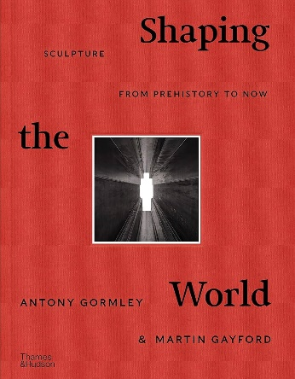

Shaping the World: Sculpture from Prehistory to Now

