Group:  P16 EW |  |  | Subject:  Horticulture | Term: 3
Teacher: |  | Ally Simpson
Curriculum: Pearson BTEC Level1 Introductory in Land-Based Studies.
Term 3: Focus – to revisit work covered on Terms 1 & 2
1 | To review work completed in Terms 1 & 2, including Health & Safety, risks and hazards of practical tasks and use of tools. To discuss the planting of the planters in Kenwood’s outside area.
2 | To understand the difference between planting bulbs and seeds and to consider the planting such that they are attractive year round.
 | To plan a herb garden with the catering
3 | To review tools and equipment for a variety of activities including carrying out propagation.
4 | To discuss where seeds come from and examples of seeds we have collected as well as ones we have bought.
5 | To review cuttings and growing tips.
6 | To discuss conditions for growth of seeds; temperature, moisture, light, oxygen, growing media.
7 | To watch a clip of ‘The Private Life of Plants’ to understand why plants survive.
8 | To do soil testing and look at different types of soil
9 | To demonstrate soil consolidation, levelling and tilth production for (a) seeding, broadcast or in drills & (b) planting.
10 | To carry out any necessary preparation of the planting medium according to instructions.

Tier Three Keywords:
propagation | temperature | oxygen

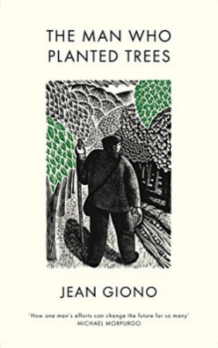
Recommended Reading:

