Group: C07 |  |  | Subject: Computing | Term: 3
Teacher: |  | James Elliott
Curriculum: Secondary Two: Fundamentals.
Term 3 focus: KS3 & Y10 Challenge. ‘Using Media to gain support for a cause’.

Programming essentials in Scratch
. The term will begin with students using different software’s to build towards a media campaign of their choice. Afterwards, students will begin and develop their programming skills through Scratch .
1 | Select the most appropriate software to use to complete a task.
2 | I can apply the key features of a word processor to format a document.
3 | Apply appropriate formatting techniques.
4 | Demonstrate an understanding of licensing issues involving online content by applying appropriate Creative Commons licences.
5 | Demonstrate the ability to credit the original source of an image.
7 | Critique digital content for its credibility.
8 | Apply referencing techniques and recognise the concept of plagiarism.
9 | Compare how humans and computers understand instructions.
10 | Define a sequence as instructions.
11 | Predict the outcome of a simple sequence.
12 | Modify a sequence.
13 | Make a sequence that includes a variable.
14 | Modify a program to include selection.
15 | Identify where selection statements can be used in a program.
Tier Three Keywords:
Campaign | Format | Bias | Platform | Advocacy | Propaganda
Call to Action (CTA) | Targeting | Reach | Algorithm | If | Condition
Sequence | Modify | Variable | Selection | Program | Code

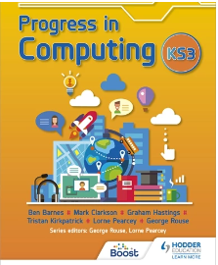
This book is designed to get you to start learning the basics in computing. It will cover all the content planned around the lessons and will provide extra support with examples of how to accomplish certain tasks in programs such as excel and PowerPoint. It will also cover networks and computer hardware/ software.
Book: ‘Progress in computing: Key stage 3’
Recommended Reading:

