Group: S2 Exploring |  |  | Subject: Health & Social Care |  | Term: 3
Teacher: |  | Jenny
Curriculum: BTEC Health & Social Care (Level 1 Introductory)
Unit: Hsc9 Providing a Creative Activity When Caring for People
Learning objectives |  |  |  | Attended | Notes | Revised
1 | Identify service users who may access creative activities in a setting and the physical, intellectual, emotional and social benefits of different activities.
2 | Describe the safety considerations of a clay modelling activity for four year olds and 78 year olds with different accessibility or disability needs.
3 | Identify ways of making different creative activities stimulating and describe how to encourage participation.
4 | Describe the professional’s role while participating in creative activities with service users e.g. safety, praise, encouragement.
5 | Apply knowledge to set up and lead a creative activity.
6 | Evaluate experience of leading a creative activity and describe strengths and next steps for development.

Tier Three Keywords:
Physical | Intellectual | Emotional | Social
Accessibility | Barrier | Empower | Encourage
Creative | Participation | Safety consideration | Stimulating

Recommended Reading:
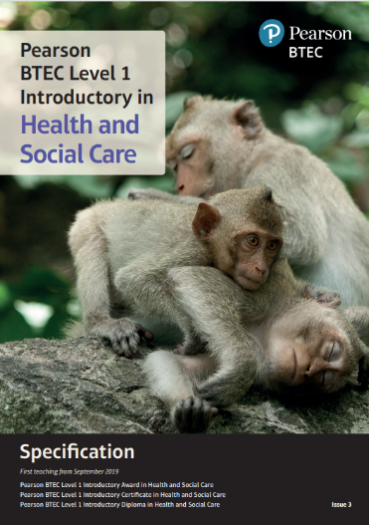

Specification-Health-And-Social-Care-Introductory-Certificate-Diploma.pdf

pp. 81-84

