Group: S2 Exploring |  |  | Subject: Health & Social Care Unit HSC 7 |  | Term:3
Teacher: |  | Joanne
Curriculum: H&SC Introductory Award, Certificate and Diploma
Unit HSC7 Making Healthy Snacks when caring for people

Learning objectives |  |  |  | Attended | Notes | Revised
1 | Find out about and plan to make healthy snacks to meet specific needs.
2 | Factors to consider when making healthy snacks that are suitable for people with specific needs.
3 | Food preparation skills for making healthy snacks to meet people’s needs.
4 | Types of people and the individual dietary needs they may have.
5 | Requirements of healthy eating.
6 | Types of healthy snacks.
Tier Three Keywords:
Shopping | Budgeting | Chopping | Grating
Weighing | Mashing | Allergy | Intolerance
Food safety | Healthy eating | Snacks | Hygiene
Recommended Reading:

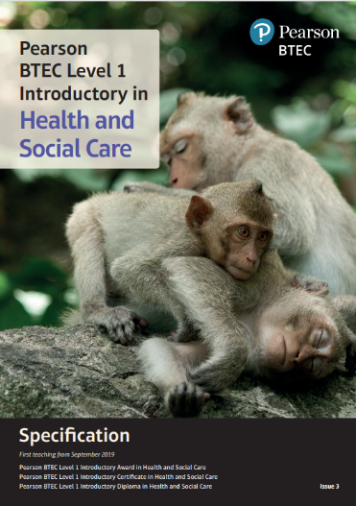
Specification-Health-And-Social-Care-Introductory-Certificate-Diploma.pdf



