Group: BR02 |  |  | Subject: English | Term: 1
Teacher: |  | Liz Lynch-Smith
Curriculum: Secondary One Deepening
Term 1 focus:
‘The Novel: understanding the text and using evidence’ &
‘War: understanding context through short extracts and transactional writing
Our first half term focuses on reading skills, and as a class we will be reading The Memory Thieves by Darren Simpson in its entirety. We start the year this way to help bring the group together in sharing a complete work of literature, and to foster a love of reading. Throughout the half term we will be developing skills of information retrieval, inference and analysis of language and structure, and students will demonstrate these skills through discussion and written responses. These written responses will vary in length with one opportunity later in the half term to write a longer answer to the question of how Simpson uses language to present theme and place.
The writing focus for half term two is transactional writing, using varied non-fiction and fiction extracts as a basis for this. The theme is war, and students will read and emulate different text types – article, review, letter –written about this topic, looking at WW1, WW2 and The Vietnam War in particular. Our reading focus is all about developing our understanding of context – for example how do the time it was written and the views of the author affect the writing.

Reading:
HT1: Understanding the text and using evidence
HT2: Situating the text in culture

2 | Across a range of reading most relevant points identified including from different places; generally supported by relevant reference
3 | Across a range of reading comments develop explanation of inferred meanings draws on varied evidence across the text
4 | Across a range of reading some general awareness of writer’s craft re structural choices; organisational features identified, explanation
5 | Across a range of reading  features of language use identified, with some explanation; some awareness of language choices
7 | Across a range of reading some explanation identifies similarities, differences between texts; and of how contexts contribute to meaning
8 | Across a range of reading: summarise, evaluate; accurate, clear understanding; valid, consistent responses to meanings, viewpoints
Writing:
HT1: Accuracy
HT2: Transactional

2 | Across a range of writing some imaginative ideas; material appropriately shaped; clear viewpoint, generally consistent
3 | Across a range of writing clear purpose; features of form show some adaptation to purpose; appropriate style maintains reader’s interest
4 | Across a range of writing material structured clearly; paragraphs; development of material; direction signalled by links between paragraphs
7 | Across a range of writing vocabulary chosen for effect; reasonably wide vocabulary used, often appropriately
8 | Across a range of writing: correct spelling of word types: grammatical function; most inflected; suffixes and prefixes; key words
Tier Three Keywords:
infer | identify | audience | theme
evaluate | purpose | present | setting
context | form | character
Recommended Reading:

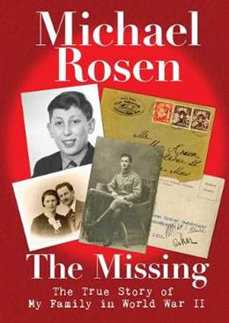
When Michael Rosen was a child, there were family stories about great aunts and great uncles in France and Poland who were there before the war and not there afterwards. When the young Michael asked what happened, his family would reply that they didn't know. How could it be that people could just disappear?
As an adult, Michael spent many years tracing his missing great uncles and aunts, and this book is the result.

