Group: EW05 |  |  | Subject: English | Term: 1
Teacher: |  | Alex Bird, Barney Thomas
Curriculum: Secondary Two Exploring
Term 1 focus:
HT1 - Novel – The Hitchhiker’s Guide to the Galaxy
HT2 - Transactional writing
This term, our studies will centre on developing both reading and writing skills through a comprehensive study of The Hitchhiker’s Guide to the Galaxy and a selection of high-quality 19th Century non-fiction extracts.
In reading, we will enhance our ability to support main ideas with appropriate textual references and quotations. Students will delve into the layers of meaning within texts, exploring how structural choices align with the writer’s themes and purposes. We will also analyse language choices to understand their overall impact on readers and engage in discussions about how context influences interpretation. A key focus will be on effectively responding to both explicit and implicit meanings.
In writing, we will focus on using a suitable level of formality for different purposes and audiences, as well as incorporating a variety of stylistic devices to enhance our writing as we work on making these choices more effective. Students will learn to clearly signal the overall direction of their texts, ensuring that paragraph construction supports meaning and purpose. We will also work on achieving accuracy in syntax and punctuation across various sentence structures, while expanding our vocabulary to include a range of varied and ambitious word choices.

Reading:
HT1: Understanding the text and using evidence
HT2: Situating the text in culture

2 | Across a range of reading commentary incorporates apt textual reference and quotation to support main ideas or argument.
3 | Across a range of reading comments securely based in textual evidence and identify different layers of meaning, with some attempt at detailed exploration of them.
4 | Across a range of reading some detailed exploration of how structural choices support the writer’s theme or purpose.
5 | Across a range of reading some drawing together of comments on how the writer’s language choices contribute to the overall effect on the reader.
7 | Across a range of reading some detailed discussion of how the contexts in which texts are written and read affect meaning.
8 | Across a range of reading understand and respond effectively to explicit and implicit meanings and viewpoints.
Writing:
HT1: Accuracy
HT2: Transactional

2 | Across a range of writing level of formality used for purpose and audience generally appropriate and a range of stylistic devices used to achieve effect, not always successfully.
3 | Across a range of writing a range of features clearly signal overall direction of the text for the reader.
4 | Across a range of writing construction of paragraphs clearly supports meaning and purpose.
6 | Across a range of writing syntax and full range of punctuation are consistently accurate in a variety of sentence structures, with occasional errors in ambitious structures.
7 | Across a range of writing range of vocabulary generally varied and often ambitious, even though choices not always apt.

Tier Three Keywords:
infer | identify | audience | theme | satire
evaluate | purpose | present | setting | Analyse
context | character | Absurdity

Recommended Reading:

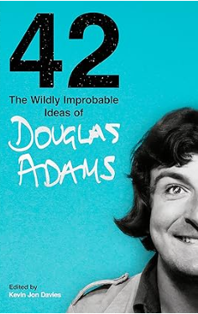

42: The Wildly Improbable Ideas of Douglas Adams

When Douglas Adams died in 2001, he left behind 60 boxes full of notebooks, letters, scripts, jokes, speeches and even poems. In 42, compiled by Douglas’s long-time collaborator Kevin Jon Davies, hundreds of these personal artefacts appear in print for the very first time.
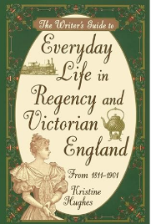

The Writer’s Guide to Everyday Life in Regency and Victorian England by Kristine Hughes

A study of everyday life in Victorian England taken from anecdotes, written histories and first-hand accounts.

