Group: NEM04 |  |  | Subject: English | Term: 1
Teacher: |  | Liz Lynch-Smith
Curriculum: Secondary One Fundamentals
Term 1 focus:
‘The Novel: understanding the text and using evidence’ &
‘Superheroes: understanding context through short extracts and transactional writing
Our first half term focuses on reading skills, and as a class we will be reading A Wizard of Earthsea by Ursula Le Guin in its entirety. We start the year this way to help bring the group together in sharing a complete work of literature, and to foster a love of reading. Throughout the half term we will be developing skills of information retrieval, inference and analysis of language and structure, and students will demonstrate these skills through discussion and written responses. These written responses will vary in length with one opportunity later in the half term to write a longer answer to the question of how Le Guin uses language to present character.
The writing focus for half term two is transactional writing, using varied non-fiction and fiction extracts as a basis for this. The theme is “superheroes”, and students will read and emulate different text types – article, review, letter – concerning both fictional and “real-life” superheroes. Our reading focus is all about developing our understanding of context – for example how do the time it was written and the views of the author affect the writing.

Reading:
HT1: Understanding the text and using evidence
HT2: Situating the text in culture

2 | In most reading simple, most obvious points identified; some comments include quotations from or references to text
3 | In most reading straightforward inference based on single point of reference; literal meaning established; personal speculation
4 | In most reading a few basic features of organisation at text level identified
5 | In most reading a few basic features of writer’s use of language identified
7 | In most reading some simple connections between texts identified; recognition of some features of the context of texts
8 | In most reading: some confidence, understanding evident; straightforward responses to explicit information and viewpoints
Writing:
HT1: Accuracy
HT2: Transactional

2 | In most writing general purpose established; main features sometimes signalled; some appropriate style and attention to reader
3 | In most writing some related points placed next to each other; openings, closings usually signalled; some logical sequencing
4 | In most writing some structure and links between sentences within sections; emerging fluidity of movement between sections
7 | In most writing simple, generally appropriate vocabulary used, limited in range; some words selected for effect or occasion
8 | In most writing: correctly spell word types: common grammatical function/ keywords
Tier Three Keywords:
infer | identify | audience | theme
evaluate | purpose | present | setting
context | form | character
Recommended Reading:

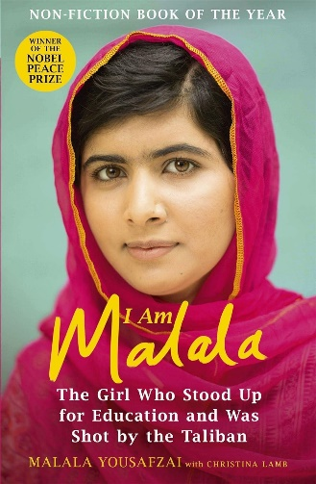
When the Taliban took control of the Swat Valley, one girl fought for her right to an education. On Tuesday, 9 October 2012, she almost paid the ultimate price when she was shot in the head at point-blank range.
Malala Yousafzai's extraordinary journey has taken her from a remote valley in northern Pakistan to the halls of the United Nations. She has become a global symbol of peaceful protest and is the youngest ever winner of the Nobel Peace Prize.
I Am Malala will make you believe in the power of one person's voice to inspire change in the world.

