Group: P16 Study Prog 3 |  |  | Subject: GCSE English Language resit | Term: 1
Teacher: |  | Helen Hawkins
Curriculum: Study Programme 3
Term 1 focus:
HT1 - Preparation for November resit. Paper 1 and Paper 2
HT2 - Focus on reading skills, covering a range of non-fiction extracts
In half-term one we will be preparing for the GCSE resit exam. We will work through both papers, using model answers, examiner reports and the mark scheme to ensure sound understanding of the requirements of each question. We will study a range of functional 19th-century non-fiction texts.as well as a range of 20th- and 21st-century prose fiction and literary non-fiction. We will also practise transactional and imaginative writing.
In half-term two we will continue to hone reading skills by exploring a range of non-fiction texts.
  Reading:
AO1 | - Identify and interpret explicit and implicit information and ideas  - Select and synthesise evidence from different texts
AO2 | Explain, comment on and analyse how writers use language and structure to achieve effects and influence readers, using relevant subject terminology to support their views
AO3 | Compare writers’ ideas and perspectives, as well as how these are conveyed, across two or more texts
AO4 | Evaluate texts critically and support this with appropriate  textual references
  Writing:
AO5 | - Communicate clearly, effectively and imaginatively, selecting and adapting tone, style and register for different forms, purposes and audiences  - Organise information and ideas, using structural and grammatical features to support coherence and cohesion of texts
AO6 | Candidates must use a range of vocabulary and sentence structures for clarity, purpose and effect, with accurate spelling and punctuation

Tier Three Keywords:
infer | identify | audience | context | purpose | analyse
viewpoint | purpose | evaluate | compare

Recommended Reading:

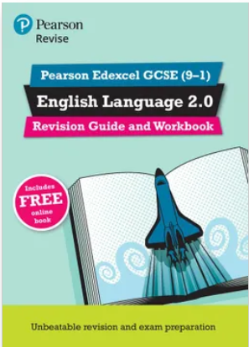
With both guidance for classroom and independent study, and exam-style questions to help develop skills and understanding of the assessment, this combined revision guide and workbook enables hassle-free classroom and independent study.
Pearson Edexcel GCSE (9-1) English Language 2.0. Revision Guide and Workbook Paperback edition by Jane Cotter, Ben Cribbin, Katy Madgwick

