Group: NEM04 |  |  | Subject: PSHE | Term: 1
Teacher: |  | Liz Lynch-Smith
Curriculum: Secondary One Fundamentals
Term 1 focus: Positive relationships, mental health and emotional wellbeing
We start the year looking at different kinds of relationships and the factors that can positively or negatively impact them, before looking in more detail at features of positive friendships and why these are important. Students will be given scenarios to work through, considering what a person might do in different social situations. There will be a focus on how social media affects friendships and how to navigate this. We will look at how relationships and sex are portrayed in the media and the impact it can have. Finally, we will learn what marriage and civil partnerhips are. All of our learning on relationships will respect and acknowledge the fact that sexuality is diverse, families and relationships come in many different forms, and this diversity is important and to be celebrated.
Our second unit has a focus on mental health and wellbeing. Students will learn strategies to manage changes associated with adolescence. We will develop our understanding of self-image and which factors impact it, including social media. We will learn how we can grow resilience in the face of setbacks and what these might be, and understand where we can seek help for hour mental health.
1 | Different types of relationships - families, friendships, romantic or intimate relationships and the factors that can affect them
2 | Signs of positive, healthy relationships and unhealthy relationships, including on-line
3 | Benefits of strong positive relationships
4 | How relationships and sex are presented in media and social media, and its impact
5 | Marriage – a legal, social, emotional commitment only to be entered into freely
6 | Protected characteristics – what they are and why diversity matters
7 | Strategies to manage changes – physical and mental - associated with adolescence
8 | Self-image and social media
9 | Building resilience to negative opinions and comments, disappointments and setbacks
10 | Language used around mental-health, stigma and overcoming barriers to seeking help
Tier Three Keywords: Marriage – a legal, social, emotional commitment only to be entered into freely
relationship | Marriage
diversity | resilience
Protected characteristic
Recommended Reading:

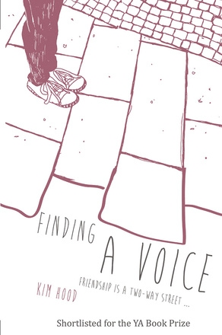
Finding A Voice: Friendship is a Two-Way Street

Two young people, each with their own very different problems, form a bond and help each other in way no one would have thought. Jo, experiencing difficulties forming friends, volunteers to help Chris. Little does she know just how much Chris will help her too.

