Group: NEC05 |  |  | Subject: Arts | Term: 1
Teacher: |  | Lizzie
Curriculum: S1 Exploring KS3
Term 1 focus: Haunted House and Stop Motion
In term 1, students will be focusing on a Halloween project where they will come up with a theme for a haunted house and a way to create their vision within their learning space. They will be focusing on art and design for this project, as well as performing to create a tense and spooky atmosphere.
After Halloween, the students will work on their creative skills to make a stop-motion film using technology and storytelling. This will require the understanding of stop-motion and how it is created.
1 | Join in with activities and games to develop confidence
2 | Understand and apply vocal and physical skills to create a character.
3 | Show applied work to peers via performance or presentation
4 | Understand and demonstrate how to build tension into a scene.
5 | Apply performance skills to create a haunted house using limited props, costumes and make up effects
6 | Design a set to create a haunted house using limited props and costumes
7 | Design and create a set for a stop-motion film using mixed-media.
8 | Understand what a stop-motion film is and how they are created.
9 | Design and create a character for a stop-motion film using non-hardening modelling clay.
10 | Attempt different styles of stop-motion by using iPads and Flick books.
Tier Three Keywords:
Tension | Performance | Animation | Present | Suspense | Modelling
Clay | Characterisation | Technology | Horror | Effects | Music
Absence | Stop - Motion | Atmosphere | Haunted | Filming | Design
Recommended Reading:
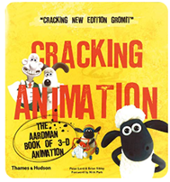
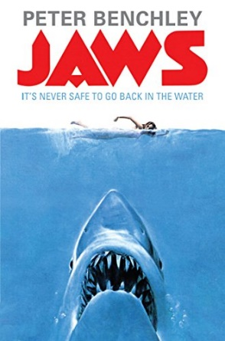

Cracking Animation by Peter Lord

Jaws by Peter Benchley

