Group: NEC06 |  |  | Subject: Arts | Term: 1
Teacher: |  | Hattie
Curriculum: Arts, Media and Music
Term 1 focus: Stop Motion Animation and Classical Music and keyboard introduction.

In term 1 students will develop skills using digital editing software with IPAD/I Movie, stop motion animation technology and apps. Students will plan and design an animation short, develop characters, set design and storyboarding skills. Along the way students reflect and investigate different types of animation and animators. Students begin to investigate the history of film and media and how technology has evolved and transformed the industry. Students also participate in a music project specifically developing knowledge of classical music, key composers and classical music historical context. Students will develop practical knowledge of the keyboard and experience playing the keyboard and reading music.

1 | Understand what a stop-motion film is and how they are created.
2 | Design and create a character for a stop-motion film using non-hardening modelling clay.
3 | Design and create a set for a stop-motion film using mixed-media.
4 | Create a storyboard for a stop-motion film.
5 | Use Ipads to shoot and edit a short stop-motion film.
6 | Take part in a showcase of stop-motion films and offer constructive feedback to other students.
7 | Know the periods of classical music and be able to sequence them chronologically.
8 | Know key composers and historical context for each of the periods of classical music.
9 | Experience and analyse music from key composers from each period of classical music.
10 | Identify middle C on a keyboard and independently play simple melodies from standard notation.
Tier Three Keywords:
Animation | Modelling | Stop-motion | Storyboard | Renaissance | Baroque
Romantic | Classical | classical | Modern | Stave | Clef
Crotchet | Minim | Quaver

Recommended Reading:

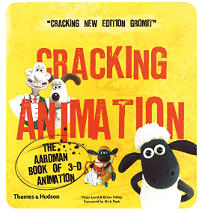Cracking Animation by Peter Lord

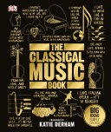

Learn about the world's greatest classical compositions and musical traditions in The Classical Music Book.

